DISPOSAL OPTIONS FOR ANIMAL TISSUES AND CARCASSES
OVERVIEW
Animal carcasses and tissue waste are generated on campus through research projects, veterinary procedures, wildlife programs, and teaching laboratories. The most environmentally friendly and cost-effective way to dispose of this waste is on-site using the University’s tissue digester. Most animal tissues and carcasses can safely be processed through digestion, but there are a few exceptions. The purpose of this document is to provide guidance to animal waste generators on:
- The process of tissue digestion
- Waste that can be safely processed in the digester
- Preparing waste for tissue digestion
- Non-tissue and carcass waste stream
- Training
- Where to get to assistance for questions and concerns regarding the digester
- Appendix A: Summary Chart of Waste Disposal Options

TISSUE DIGESTION
The tissues digester (A) is located on the St. Paul campus as part of the Veterinary Diagnostic Laboratory (VDL). It is a large vessel that processes animal waste through alkaline hydrolysis, using heat, pressure, and a strong alkaline solution that breaks down animal tissues and carcasses (A). The resulting material is a liquid mixture of amino acids, peptides, sugars, nutrients, and bone fragments. The liquid separated from the bone fragments, which can be disposed via the city sewer system. The bone fragments are very brittle, so they can be easily broken up and composted or used as fertilizer (B).

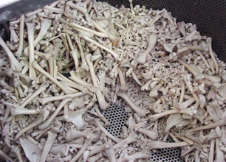
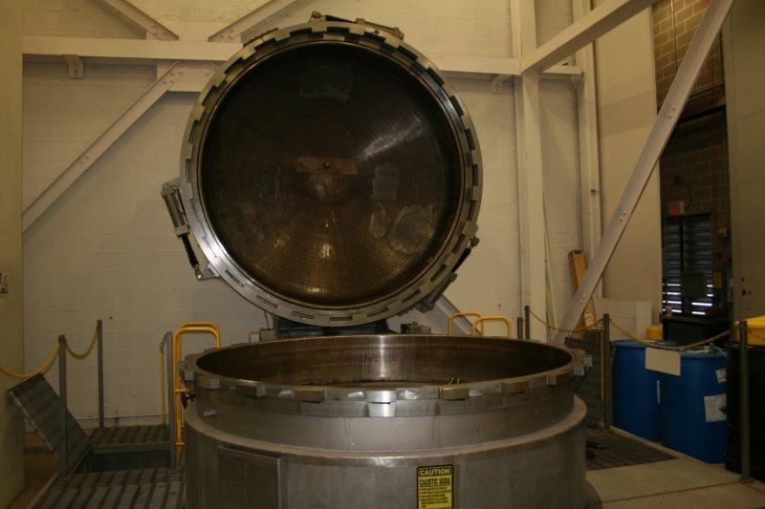
(A) 7000-pound capacity tissue digester (B) Remaining bone fragments

WHAT KIND OF WASTE CAN SAFELY BE SENT TO THE DIGESTER?
Most of the animal waste can be sent to the digester. Tissue digestion is a sterilizing process that will effectively inactivate prions and infectious agents. It is important that only animal tissue, carcasses, and pink-colored digestible bags (C) enter the digester. Plastics, metals, rubber, and other non-tissue materials will clog the pipes that allow the digester to drain. Chemicals should never go into the digester; however, the exceptions are liquid prion waste, formalin preserved tissues and carcasses if the excess liquid has been collected as hazardous waste to be processed through proper hazardous waste disposal procedures. Digestible bags should be collected in designated red bins (D) in Research Animal Resources (RAR) areas or placed in the designated animal waste coolers. Materials such as ear tags, IVs, tubing, gauze, medical devices, and implants should be removed prior to disposal. These materials can be disposed of in the non-tissue biohazardous waste stream (see next section).
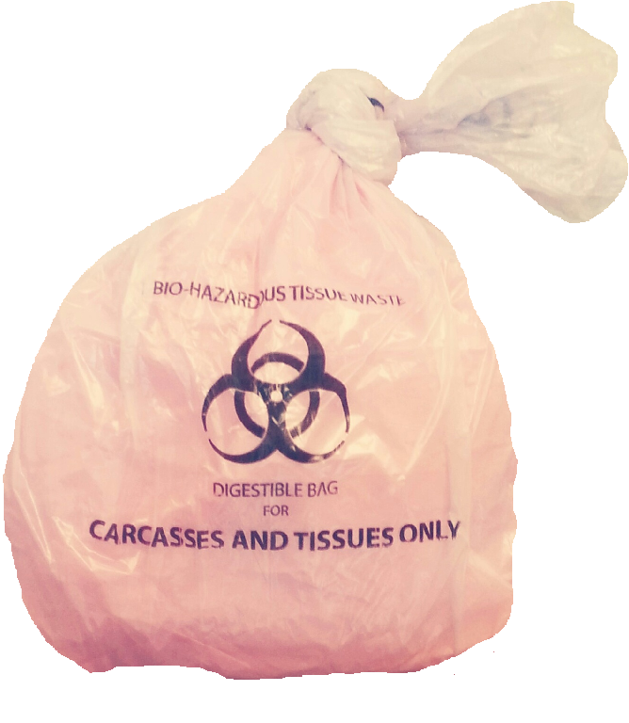
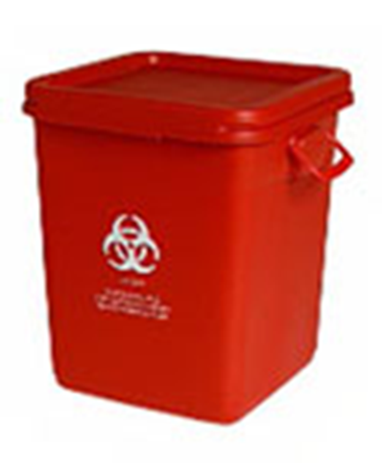

(C) Digestible bag safe for digestion (D) Red collection bin for digestible bags

WHAT KIND OF WASTE CAN NOT BE SENT TO THE DIGESTER?
Animal carcasses and tissue that contain high hazard chemicals and chemotherapeutic agents must NOT be sent to the digester. Some tissue on campus is preserved by plastination; plastinated tissue and carcasses must NOT be digested. There will be high hazard yellow waste bags (E) and bins (F) available for animal waste that is not safely digestible. Any carcasses and tissues with implants or medical devices that cannot be removed should go in yellow bags/bin as well.
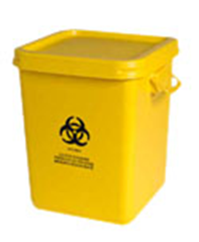
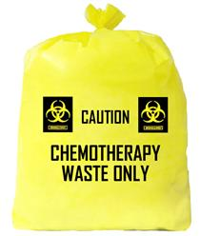

(E) Yellow bag for non-digestible tissues & carcasses (F) Yellow bin for non-digestible & high hazard waste

PREPARING WASTE FOR TISSUE DIGESTION:
Small animals and loads
1. Remove any material that is not tissue from the tissues and carcasses (pads, IVs, medical devices or implants, gauze, tubing, ear tags). Whenever possible, use tattooing or notching as an alternative to ear tags.
2. Place the carcasses and tissue in small digestible bags and tie them closed. Double bag the waste if necessary, to prevent leaks and tears. You can purchase the small digestible bags (17 x 16) through UMarket #GC20009.
3. Bring the bags to the nearest red biohazard collection bin or storage cooler. The majority of the animal waste collection bins and coolers are located in RAR areas.
4. Collection bins will be lined with a large digestible bag provided by Facilities Management (FM).
5. Collection bins must NOT exceed 50 pounds. The large liner bags should be tied off when the bin is ¾ full or at the maximum weight limit. Place the appropriate lid on the bin and tightly seal shut.
Large animals and loads
1. Remove any material that is not tissue from the carcasses (pads, IVs, medical devices or implants, gauze, staples, tubing, ear tags)
2. Place the carcasses and tissue in large digestible bags and tie them closed. Double bag the waste if necessary, to prevent leaks and tears. You can purchase large digestible bags (40 x 46) through UMarket #GC20010
3. In some instances, large animals or loads of waste can be brought directly to the VDL for processing. Red carcass bins must NOT exceed 50 pounds or be more than ¾ full under any circumstances and lids need to be closed completely. Please contact VDL at 612-625-8787 for questions regarding large animal preparation for tissue digestion or to arrange a direct drop-off of a large load.
DISPOSAL OF NON-DIGESTIBLE ITEMS: NON-TISSUE BIOHAZARD WASTE STREAM
Gloves, tubes, padding, gauze and medical devices used in animal procedures must either be autoclaved on site or disposed of in biohazard red bags/gray bins (G). Any needles, metal clips, ear tags or items with sharp edges must go into a biohazardous sharps bin. Solid materials that contain trace amounts of high hazard chemicals, chemotherapeutic agents, prions, low molecular weight biological toxins, animal bedding and waste must be disposed in the yellow/high hazard waste stream (H).
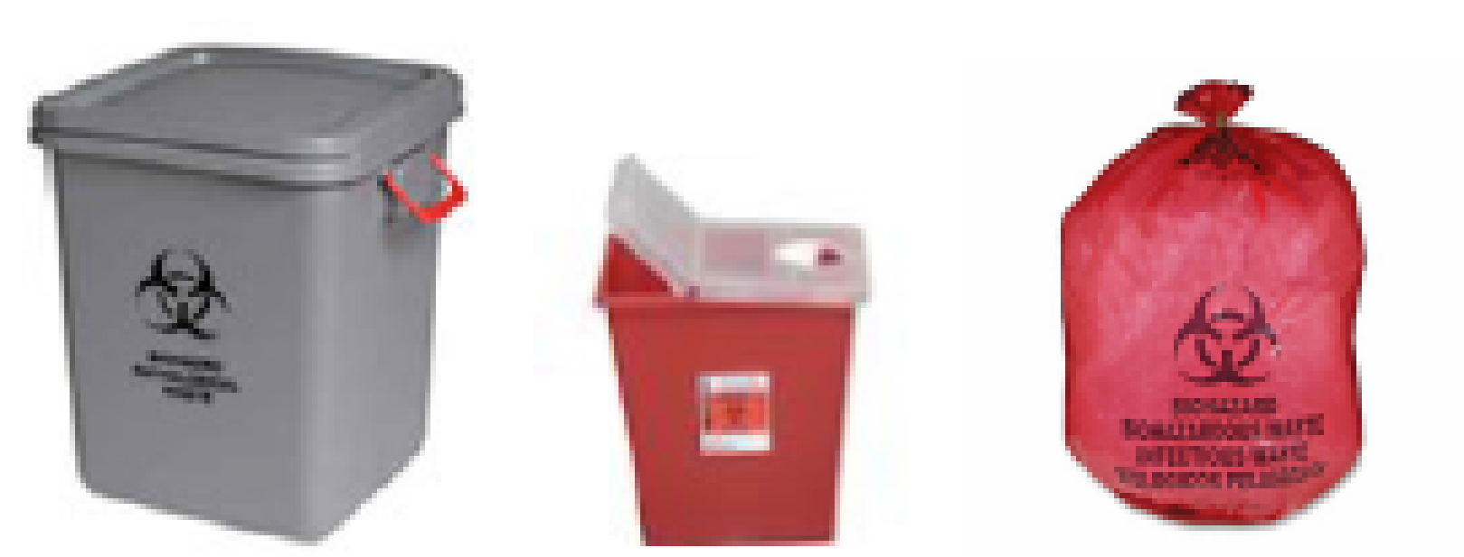
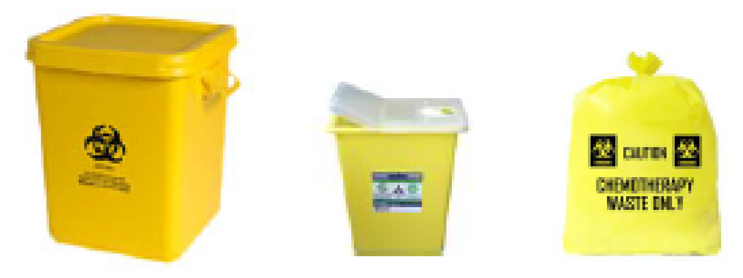

(G) Non-digester biohazard waste stream (H) High hazard items & carcasses waste stream
HUMAN TISSUE
Human tissue must NOT go into the tissue digester. Contact the University’s Anatomy Bequest Program for questions regarding human tissue, organs, or body parts.
TRAINING
Anyone who will be generating or handling animal tissues and carcasses on campus must have special training on how to prepare waste for the Tissue Digester. Most of this training will be provided through RAR. RAR may not be affiliated with diagnostic, veterinary, or wildlife facilities. If you work in one of these areas, please take online Biological and Infectious Waste training through UHS. If you have questions regarding training, contact UHS at 612-626-6002 or uhs@umn.edu.
QUESTIONS OR CONCERNS
For injury accidents or large spills (>100 mls) call 911

Contact RAR: compmed@umn.edu or 612-640-9100 with any questions regarding animal tissue and carcass waste
Contact UHS: uhs@umn.edu or 612-626-6002 for questions regarding:
- Small spills (<100 mls.), leaks, or incidents involving biohazardous or tissue digester waste
- Training questions, if you’re not affiliated with RAR
- Disposal methods or waste preparation for tissue digestion
- To report any improperly handled waste (i.e., non-digestible material observed in bags or bins more than 50 pounds.

Contact Facilities Management at 612-624-2900 for:
- Questions regarding bin delivery or pickup
- Making special collection arrangements
- If you need additional Gray, Red or Yellow bins

Contact UMarket to order digestible bags:
- Small digestible bags (17 x 16) #GC20009
Large digestible bags (40 x 46) #GC20010
For other questions contact: digester@umn.edu

APPENDIX A: SUMMARY TABLES OF ANIMAL WASTE DISPOSAL OPTIONS

ANIMAL TISSUE AND CARCASSES
TISSUE DIGESTER WASTE | 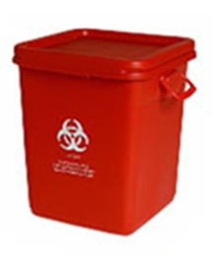  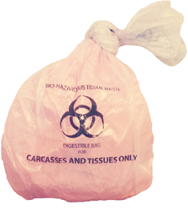
OK | Digestible bags containing animal:  - Carcasses  - Organs  - Tissues  - Trace amounts of blood  - Formalin fixed-tissue (liquid formalin must be collected separately and processed as hazardous chemical waste)  - Carcasses or tissue containing prion disease
NO | - Plastic (tubing, gloves)  - Paper (wipes, towels)  - Metal, clips, sharps, glass  - Plastinated tissue/carcasses  - Tissue or carcasses that contain chemotherapy agents or high hazard chemicals  - Liquid chemical waste including formalin  - Tissue or carcasses with unrecoverable medical devices or implants

WASTE CONTAINING TRACE AMOUNTS OF CHEMOTHERAPY AGENTS OR HIGH HAZARD CHEMICALS
YELLOW BAGS/SHARPS CONTAINERS/BINS FOR INCINERATION | 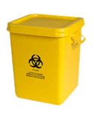  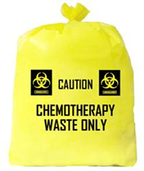  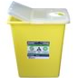
OK | Waste containing chemotherapy agents/high hazard chemicals/low molecular weight biological toxins  - Carcasses, tissues and organs  - Carcasses and tissues with unrecoverable medical devices or implants  - Pads, gloves, bedding  - Any non-tissue waste items containing trace amounts of high hazard chemicals, chemotherapy agents, prions, or low molecular weight biological toxins  - Metal clips, ear tags, needles (sharps containers only)
NO | - Pourable liquid chemicals of any kind (contact UHS for liquid chemical waste processing)

BIOHAZARDOUS NON-TISSUE WASTE FOR OFF-SITE PROCESSING
RED BAGS/SHARPS CONTAINERS/GRAY BINS FOR OFFSITE  AUTOCLAVING | 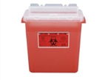  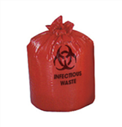  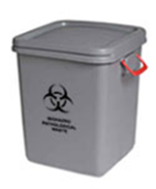
OK | Non-Tissue/Carcass Biohazard Waste  - Pads, gauze, tissue, plastic, paper  - Disposable PPE including gloves, gowns, masks, etc.  - Metal clips, ear tags, needles (sharps containers only)  - Any non-tissue potentially infectious waste
NO | - Animal tissue, organs, carcasses  - Prion waste of any kind  - Chemical waste or materials containing chemical residue  - Solid waste containing low molecular weight biological toxins
For information regarding on-site Autoclaving of non-tissue/carcass biohazardous waste, visit the BOHD website.

