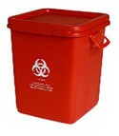
Animal Tissue and Carcass Waste Disposal

Waste Container | 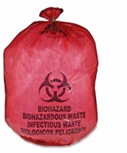  Red Barrel Red Bag | 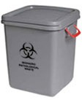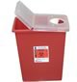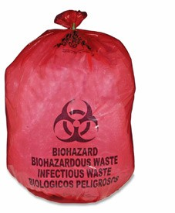  Grey Barrel Sharps Container Red Bag | 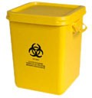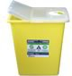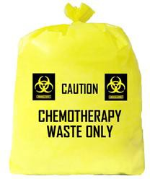  Yellow Barrel Sharps Container Yellow Bag
Method | Offsite Processing | Autoclave Offsite | Incineration
OK: | Animal tissues, organs and carcasses only!  - Animal tissue and carcasses Note: for preserved specimens, fixatives must be collected separately & processed as hazardous chemical waste | Non-tissue waste items containing residual amounts of animal tissue, blood, bone fragments, etc.  - Pads, wipes, gloves, bedding  - Metal clips & sharps  (Sharps container only) | High hazard animal tissue, organs & carcasses; both tissue & non-tissue waste containing chemotherapy drugs, carcinogens, prions, or low molecular weight biologically-derived toxins.  - Plastinated animal tissues  - Pads, gloves, bedding  - Metal clips, glass & sharps (sharps container only)
NO:  For more information, email HSRM@umn.edu | - Animal waste containing prions  - Sharps, glass, metal  - Plastinated tissue/carcasses  - Animal waste containing Chemo drugs, low molecular weight biological toxins or carcinogens | - Animal tissue, organs, carcasses  - Waste containing prions, or low molecular weight biologically- derived toxins.  - Chemical waste or materials containing chemical residue | - Liquid chemical waste

Revised: February 1, 2024

