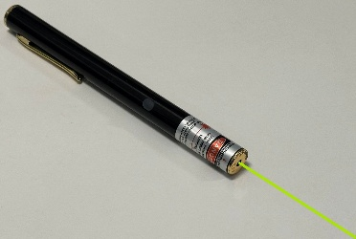
Laser Pointers

Revised: Feb 2026
Laser pointers are commonly used as visual or instructional aids, often in a lecture hall setting or outdoors and are useful for drawing the audience’s attention to a specific location. Most pointers are low powered and do not present serious risks to the eye. However, optical hazards, including glare, flash blindness, and startle effects are a possibility if a laser pointer is used improperly.

How is Laser Light Different from Ordinary Light?
Laser light has three important properties that separate it from ordinary light: it is monochromatic (one color), directional, and its energy is highly focused. Ordinary light, such as from an incandescent light bulb, is emitted as a broad spectrum of wavelengths (white light) and in all directions. As this light is emitted in all directions, it is not very focused, and the amount of energy imparted upon a given area is small. Laser light, on the other hand, takes the form of a well-defined beam which is highly directional and focused. This results in all the laser’s energy being delivered to a very small, concentrated area. Exposure to such a beam could result in injury to the eye or skin (depending on the wavelength and power).

How to Identify a Laser Pointer that is Acceptable to Use?
A conforming laser pointer will have the required FDA warning label somewhere on its body, and should contain information on the class, power output, and wavelength (see Fig. 1). There should also be a statement that the device complies with Chapter 21 CFR (Code of Federal Regulations). Class 1 or Class 2 laser pointers with an output of less than 1 milliwatt (mW) will have a “Caution” label, while a Class 3R (formally Class 3a or IIIA) laser, with an output of between 1 and 5 milliwatts (mW), will have a “Danger” label. If you purchase a laser pointer that arrives with an incomplete or missing warning label (see Fig. 2), do not use it and contact the Laser Safety Officer (lso@umn.edu).
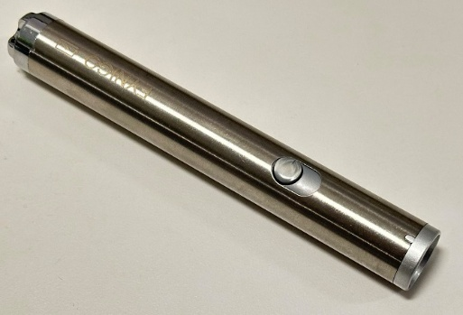
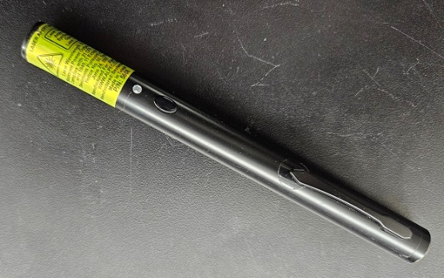

Fig.2. Laser pointer with missing label.
Fig 1. Laser pointer with a complete label.

The Food and Drug Administration has set a limit of no more than 5 mW for the safe use of laser pointers. It is strongly recommended that personnel limit their use to red (630—680 nm) Class 1 or Class 2 laser pointers. Any laser pointer that exceeds 5 mW is considered hazardous (Class 3B or 4) and should not be used outside of a research laboratory.

Beware of Inexpensive Laser Pointers!
Laser pointers, often those with wavelengths of 532 nm (green), that are priced low and seem like a good deal, may output a greater power (or additional wavelengths) than advertised. For example, a department purchased several low-cost green laser pointers for their lectures. When tested with a power meter, one laser pointer, labeled as having an output power of less than 5 mW, emitted a beam with a power of close to 70 mW! (see Figs. 3 and 4)
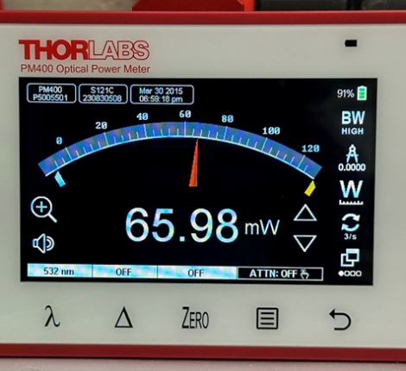
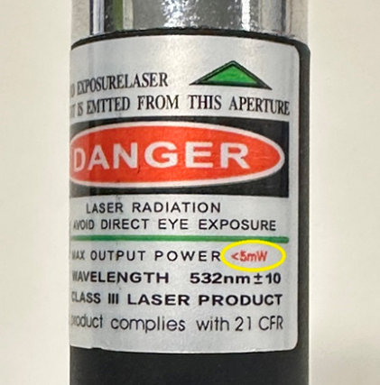

Fig. 3. Laser pointer labeled as < 5 mW output.
Fig. 4. The measured output of the pointer.

If you would like to confirm that your pointer is producing a safe level of laser light, the Laser Safety Officer can visit your location and perform a power measurement of your device.
- Laser Pointer Test Request Form

Steps for Using a Laser Pointer Safely
- Regardless of the laser power or classification, do not look directly into the beam.
- Never aim the laser pointer toward anyone, even when powered off.
- Do not point toward mirrors or other reflective surfaces. Doing so may result in the beam being unintentionally directed towards spectators.
- All laser pointers should be activated using a momentary push button, not an on-off switch. A momentary push button will prevent the beam from being accidentally directed toward the audience when the instructor is not pointing at the presentation (screen or other inanimate objects) if they should forget to move the switch to the ‘off’ position.
- If using a laser pointer outdoors (birding, astronomy), never point in the direction of aircraft, ground vehicles, or buildings.
  - It is a federal crime to intentionally aim a laser pointer toward an aircraft or flight path.
- Do not view the beam from a laser pointer with an optical device, such as a microscope or binoculars.

Resources
If you would like more information on laser pointers, please contact the Laser Safety Officer (lso@umn.edu).
ANSI Z136.1 - 2022 Safe Use of Lasers (available for review at Health, Safety, and Risk Management)
FDA - Illuminating Facts About Laser Pointers

