Lasers in the Lab

Revised: Feb 2026
Lasers emit light (visible and invisible) through optical amplification, and are used for many purposes, including medical, cutting, measurements, and communication.

Hazards of Lasers
Eye damage – The primary hazard of working with lasers is the potential for eye damage. When a laser beam strikes the eye, damage to the cornea, lens, or retina can occur, depending on the wavelength. Damage can range from temporary effects, such as dark spots in vision and flash-blindness to long term effects including permanent blindness, blurry vision, or other permanent visual problems.
Skin burns and fire – Lasers can burn skin, possibly severe enough to leave permanent scars. There is also a risk of developing skin cancer if exposed to certain UV lasers. High-power lasers can ignite combustible materials.
Other Physical Hazards – Many lasers use high voltage power sources. Because of this, there is a risk of electrical shock, resulting in serious burns, long-term damage, or death. Other systems use high-pressure arc lamps, which can cause explosions. Lasers also often have many cords, which can create a tripping hazard
Chemical and Inhalation hazards – Some lasers use toxic gases or dyes as part of their systems. If you are using lasers to cut or burn material (inorganic or biological), it can generate air contaminants that may also be harmful.
Optical instruments that focus light make lasers more dangerous. Reflections can be dangerous as well.

Laser Classifications
Class | Description | Hazard | Example
Class 1 | Very low power or fully enclosed | No possibility of harm | CD player
Class 2 | Output power < 1 mW. Staring into the beam for a long period could cause damage | Eye damage possible but unlikely | Laser pointer or barcode scanner
Class 3R (3A) | Output power between 1 and 5 mW | Damage to eye after 2 minutes of exposure | Alignment laser, garage door sensor
Class 3B | Average output power between 5 mW and 500 mW | Permanent eye damage in < 10 ms | Research laser, e.g., spectrometer
Class 4 | “High-powered”  Average output power > 500 mW | Severe damage to eye and/or skin likely | Research laser, laser cutter, laser welder

Class 3B and Class 4 Lasers are Hazardous
New laser systems should be evaluated by the University Laser Safety Officer (Brian Andersson, lso@umn.edu). SOPs are needed for Class 3B and 4 laser experiments to identify appropriate eye protection, signage, and for other laser activities, including alignment and cutting.

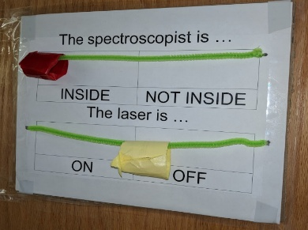
Signage
Figure 1—Door sign indicating when laser is on or off
All labs with Class 3B or Class 4 lasers must post appropriate laser signage at entrances. Best practice is to also post additional signs to indicate when the laser is powered up or active (required for Class 4 laser labs), so others entering the area are aware that it is in active use. (Figure 1)

Training
- Users must complete the General Laser Safety (UHS 303) online training course available through HSRM. https://training.umn.edu/courses/10170
- ALL lab personnel must be offered lab-specific laser training at least annually.
- Non-users should be trained to knock on the door of all laser spaces before entering.

Eye Protection
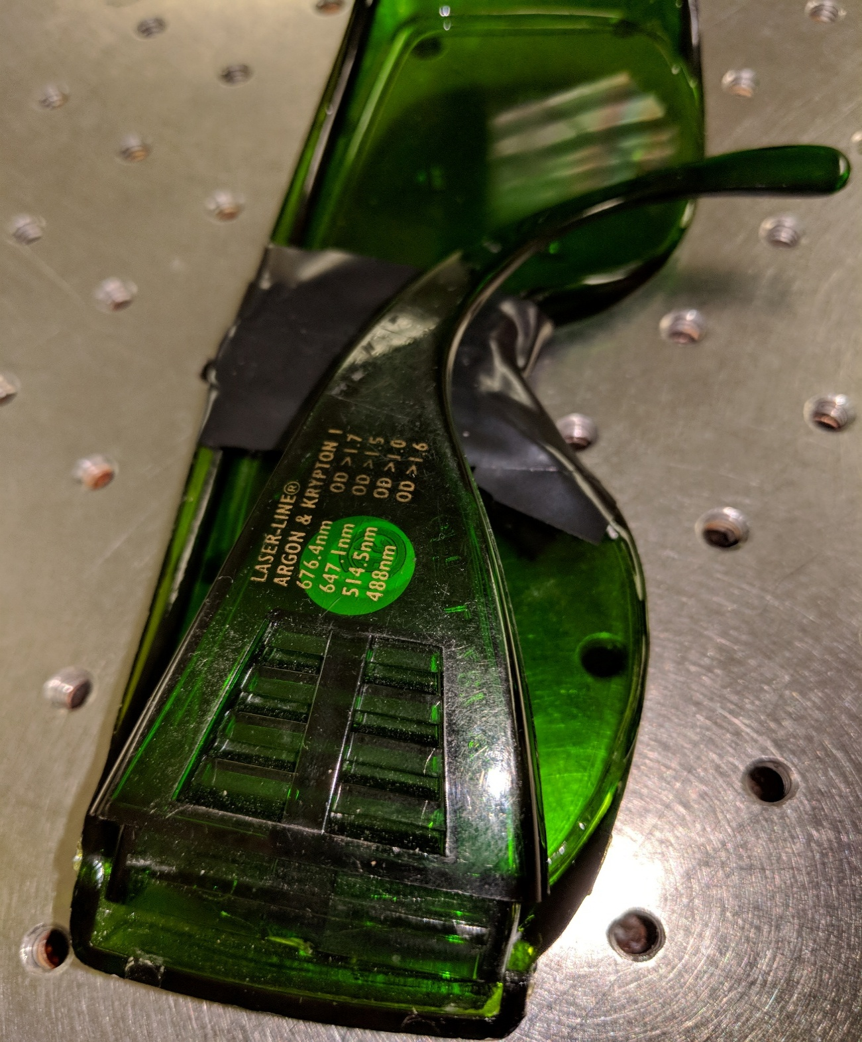
- All laser users must wear eye protection specified by the signage, SOPs, and training specific to the laser you will be using. Do not assume the protection provided by the laser vendor is the proper type. The correct type is determined by the wavelength, viewing conditions, and the power/energy of the laser.
Figure 2- eye protection label
- All eye protection must be labeled with the optical density and wavelength that it protects against, as shown in Figure 2 (ANSI Z136).
- Note- Different lasers may need different types of eyewear. Even the same laser can require different types of glasses, if it operates at more than one wavelength. You may not be able to use the same glasses you used with another laser, or in another lab.

Work Area
- Remove all reflective materials. Check yourself for any rings, watches, earrings, or other shiny/reflective jewelry. Check the optical table itself for laminated paper, metal parts, glassware, goggles, or tools.
- Remove combustible materials, like paper and cardboard, that could be ignited by the laser.
- Check that all controls are working properly. This includes any safety interlocks, beam enclosures/covers, beam stops, and other safety mechanisms.
- The laser beam should be positioned below eye level for people who are standing or sitting.
- All elements on the optical table must be secured. If the table is bumped, or something is dropped on it, the beam may become misdirected potentially causing harm.

Using Lasers
- Always check your eye protection is the correct optical density for the laser wavelength you are using. Do not rely on the color of the lens.
- Move carefully when adjusting any part of the laser setup during work to avoid misalignment.

