Laser Safety in Educational Settings

Introduction
Lasers, ranging from pointers to research-level systems, may be found in educational settings, including lecture halls and teaching labs. Certain factors must be considered when using lasers in a setting where potentially large audiences may not be afforded the same personal protection normally found in a research lab. This guidance document will provide information on the safe use of lasers in the following settings:
- Lecture halls
- Classrooms
- Undergraduate teaching labs
- Graduate teaching labs
Content within this document fulfills requirements found in the laser safety standards ANSI Z136.1 - Safe Use of Lasers and ANSI Z136.5 - Safe Use of Lasers in Educational Institutions.

Definitions
Beam stop - An opaque device used to absorb laser radiation at a specific location. It can be used to prevent beams traveling toward neighboring workstations or into a spectator area.
Classroom environment - A classroom or closed room in which students are seated, and an instructor is present to provide supervision.
Educational research laboratory - Educational labs at the University of Minnesota devoted to continuing research projects using Class 3B or Class 4 lasers. Details on how lasers are classified can be found in the Appendix at the end of this document.
Laser-controlled area (LCA) - A laser use area in which Class 3B or Class 4 lasers are housed. The activities and occupants within are controlled and supervised. Potential harmful exposure is possible within the area.
Laser demonstration - A display or experiment using a laser for teaching purposes or concept development.
Laser pointer - A hand-held laser used to specify a discrete point or location, primarily used in classrooms and lecture halls.
Lecture hall environment - A large room with a well-defined student seating area and a separate demonstration area for the instructor.
Lesson plan - A standard operating procedure (SOP) used in a lab, classroom, or lecture hall environment.
Spectator - An individual observing a laser in operation and may lack appropriate laser safety training.
Teacher - Any faculty member, instructor, or teaching assistant (TA) responsible for the operation of a laser.

Roles and Responsibilities
Laser Safety Officer (LSO) - The person that manages the laser safety program at the university (Brian Andersson - lso@umn.edu). The LSO will approve the use of Class 3B or Class 4 lasers used in educational settings, conduct periodic inspections of laser equipment and locations, and stop any operations deemed unsafe.
Demonstration and Lab Supervisors - Supervisors will ensure all instructional staff and Teaching Assistants (TAs) have received mandatory laser safety training, both general and laser-specific. The supervisor is also responsible for developing lesson plans detailing the safe use of lasers in a classroom, lecture hall, or teaching lab. Will maintain an accurate inventory of all Class 3B and Class 4 lasers and provide this inventory to the LSO.
Instructor/Teaching Assistant - Will receive instructions for the safe operation of the laser experiment prior to class. The instructor or TA will ensure students are always supervised and that hazard controls and lesson plans have been communicated to the students. Any incidents involving lasers are to be reported to the supervisor and LSO immediately.

Laser Pointers in the Classroom
Laser pointers are frequently used in classrooms to emphasize information contained in projected computer lecture presentations or in simple lecture demonstrations. Care must be taken that the laser is never pointed toward the class to prevent potential harmful exposures. Additional information on laser pointer safety can be found in this Fact Sheet. Some guidelines to follow when using a laser pointer include:
- Permissible classes: Only Class 1 or Class 2 laser pointers are generally permitted. Class 3R laser pointers are allowed but discouraged. Class 3B and 4 pointers are strictly prohibited.
  - It is strongly recommended that Class 1 or Class 2 pointers with a wavelength of around 650 nm (red in color) are exclusively used.
  - If a green Class 3R pointer is to be used, its output power must first be verified by the LSO.
- Purchasing laser pointers: Purchase laser pointers only from reputable laser or scientific vendors. Avoid purchasing from online stores that sell high-power laser pointers or inexpensive pointers from Amazon where the quality of the laser cannot be confirmed. Never purchase or use a pointer that is missing its warning label. Contact the LSO with any questions or for recommendations on purchasing laser pointers.
- Verify output power: If you have purchased a laser pointer to be used in lecture, contact the Laser Safety Officer to verify the output of the laser matches the power indicated on the manufacturer’s label.
  - Lasers on campus have been found to output significantly more power than the label indicated. Any exposure to such beams would result in permanent damage to the eye.
- Prohibited actions: Never aim the pointer directly at a person's eyes, cameras/projectors, or doors and windows.
- Handling and storage: Only use laser pointers with momentary power switches (that is, the laser turns off when your thumb leaves the switch). Turn off and store the laser pointer when not actively presenting.

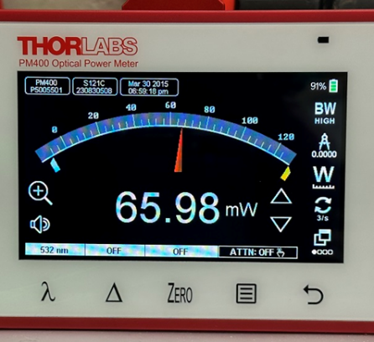
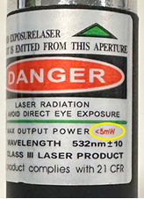

The actual output of the laser pointer
A pointer labeled as less than 5 mW output

Laser Demonstrations in Lecture Halls and Classrooms
When setting up a laser for a classroom demonstration, care must be taken to protect both the laser user (instructor) and the students in the audience. Classrooms and lecture halls accommodate class sizes ranging from 10 students to over 200. As it would be impossible (or at the very least, extremely impractical) to provide protective equipment for every student, laser demonstrations must be set up and operated in a manner that the students in the audience are not exposed to potentially harmful levels of laser radiation. The demonstration supervisor and instructor must follow these guidelines when performing any laser experiment:
- Use Class 1 or Class 2 lasers whenever possible.
- Class 3R lasers are to be used only when necessary and are handled with caution.
  - Class 3R lasers are generally considered lower in hazard. However, prolonged and intentional eye exposure can result in injury.
- Class 3B and Class 4 lasers are prohibited in lecture halls and classrooms. Class 3B and 4 lasers can quickly cause physical harm to unprotected spectators or damage to building infrastructure.
- Do not use lasers with invisible beams unless necessary. For alignment purposes, use a Class 1 or Class 2 visible laser to trace the path.
- When setting up the demonstration, verify the beam path will not encounter any reflective surfaces not part of the demonstration.
- Trace the beam path to confirm no portion of the beam is directed or reflected toward students, doorways, or windows.
- If the laser demonstration is set up by someone other than the instructor (e.g., the demonstration manager), the instructor is to receive safety and operating instructions prior to the lecture.
- The instructor is to verbally warn the class that a laser is about to be activated. Confirm that there are no students in the demonstration area.
- Activate the laser only when ready to perform the demonstration. Switch the laser off immediately at the conclusion of the experiment.
- Unplug the laser or remove the activation key (disable the laser) at the conclusion of the experiment. Students often come to the front of the classroom after class to ask questions. Disabling the laser will prevent students activating the potentially unsupervised laser after the lecture is over.
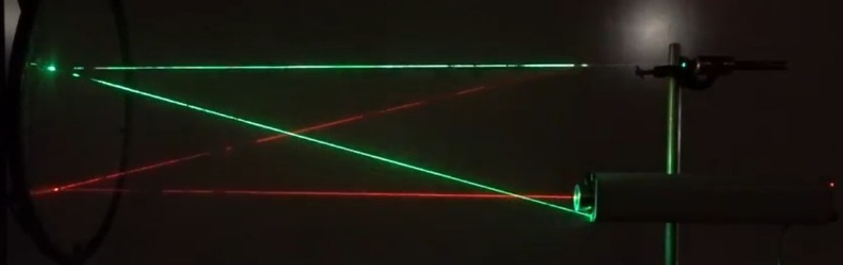
If there are doors to the lecture hall or classroom that would allow a student to directly enter the demonstration area, it is strongly recommended that a caution sign indicating a laser is in use be placed on the door outside of the room.

Physics lecture demonstration showing parallel lasers reflecting off a large concave mirror.

Lasers Used in Teaching Labs
The risk of inadvertent exposure to laser light is increased in teaching labs as students may be expected to work closely with the laser setup. In some situations, there may be multiple experimental setups with several lasers activated at the same time. In addition, students, particularly undergraduates, have most likely not received prior laser safety training. It is important (and required) that the instructor or teaching assistant is trained in laser safety and can clearly explain to the students, before the students have access to a laser, how to use the laser system(s) properly.
Please follow the guidelines below when modifying existing, or developing new, laser experiments and/or configuring the lab room in which the experiments will take place.
- If multiple lasers are required to be set up in the same teaching lab room, ensure that all beams are directed away from other student workstations or interrupted by barriers or beam blocks.
- Whenever possible, only use Class 1, Class 2, or Class 3R lasers.
  - Note: Class 3R lasers, though lower in hazard than Class 3B or 4 lasers, are still capable of causing permanent damage to the eye if it is exposed to a beam for an extended period.
- Unless a particular experiment requires the use of an invisible beam, visible lasers should be exclusively used.
- If a Class 3B or Class 4 laser is required for an experiment, additional safety controls must be implemented, including, but not limited to:
  - Appropriate PPE
  - Signage
  - Window coverings
  - Additional training
- Class 4 lasers should rarely be used and only when the beam is completely enclosed and there is no possibility of accidental exposure.

Lesson plans involving the use of Class 3B or Class 4 lasers in a teaching lab must first be approved by the LSO. All written lesson plans, regardless of laser power, should contain the following elements:
- Learning objective
- Required tools
- Description of equipment set-up
- Methods for checking on the operational status of equipment
- All safety protocols to be followed including the use of protective eyewear
- If pedagogy allows, a detailed experimental procedure
  - Sufficient information is to be provided so the experiment can be successfully completed
- Verbal review of all safety rules with the class before the experiment begins
- Post-experiment clean-up checklist
It is important to review general laser safety rules with the class before work (with any laser) begins. Consider dedicating 30-60 minutes to allow for a thorough discussion of safety protocols if students will be operating Class 3B or Class 4 lasers. The content of your safety training should consist of elements including, but not limited to, the following:
- Removal of jewelry or other reflective accessories, such as ID tags. If Class 4 lasers are in use, removal or tying back of loose clothing items (e.g., ties or scarves) to prevent them from hanging into the beam path.
- Never looking directly into the beam
- To never leave a powered laser unattended
- Avoid viewing specular reflections
- Only operating the laser in the approved location and configuration
- To never aim the beam through an interior/exterior window or toward a door
- When not in use, disconnecting power or removing the activation key
Teaching labs using multiple lasers must be set up in a thoughtful manner. It is important that lasers (all classes) are never aimed at any student or neighboring workstations. The following pages will illustrate safe ways of configuring teaching labs with multiple Class 2, 2M, or 3R lasers (Figs. 1 and 2). Figure 3 illustrates the proper way of setting up a Class 3B or Class 4 teaching lab.

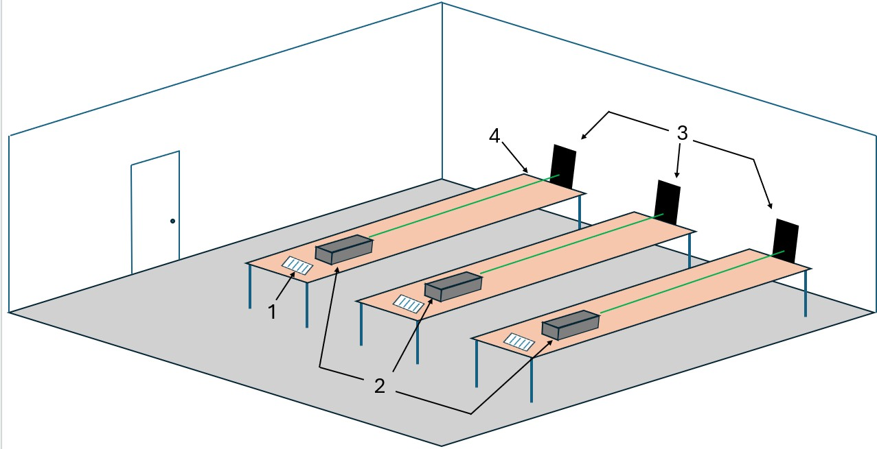

Fig. 1 Teaching lab with multiple Class 2 or Class 2M lasers

- Experiment instructions | - Beam stops to prevent reflections
- Multiple Class 2 or 2M lasers | - Tables pushed against the wall
Legend:

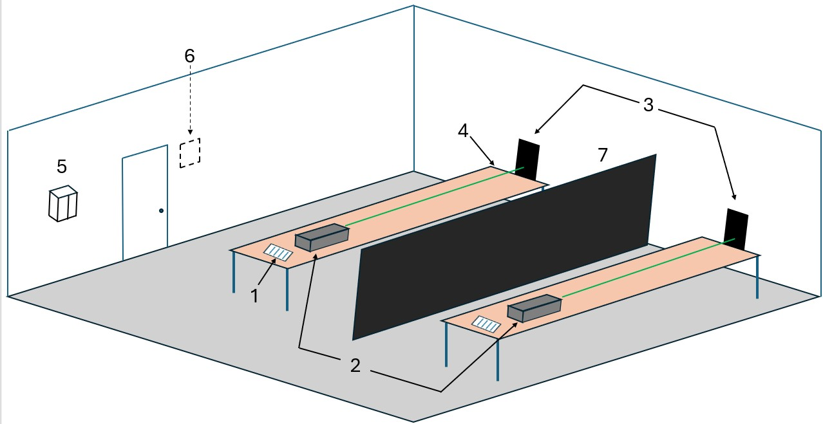

Fig. 2 Teaching lab with multiple Class 3R lasers and a partition between lab stations

- Experiment instructions
- Multiple Class 3R lasers
- Beam stops
- Table against wall | - Exterior ‘CAUTION’ sign
- Laser eyewear | - Table partition
Legend:

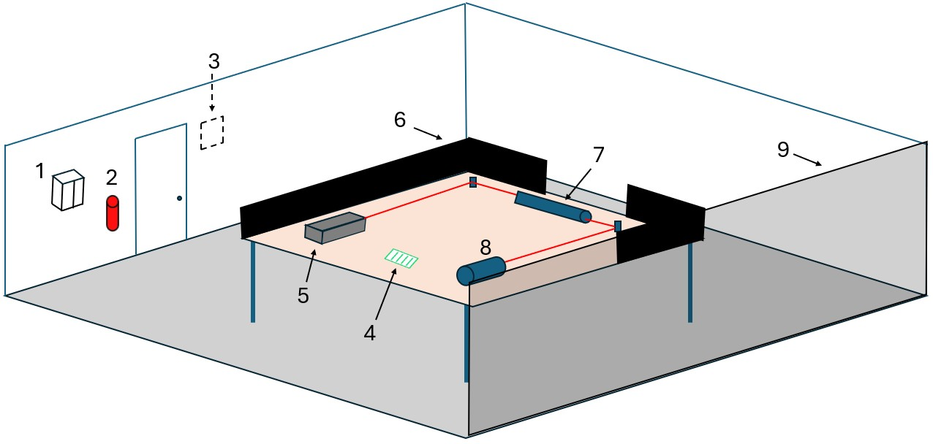

Fig. 3 A teaching lab with a Class 3B or Class 4 laser

1. Laser eyewear storage | 4. Experiment directions | 7. Mounted beam tube
2. Fire extinguisher | 5. Class 3B or 4 laser | 8. Target (beam terminated)
3. Exterior ‘DANGER’ sign | 6. Beam stops | 9. Laser-rated curtain/barrier
Legend:

Class 3B and Class 4 Laser Labs
Teaching labs using Class 3B or Class 4 lasers will be required to implement controls as specified in the University Laser Safety Program, including an establishment of a Laser Controlled Area (LCA), enhanced training for instructors and students, and the use of required PPE. The instructors for these labs will be required to complete online General Laser Safety training.
In small lab rooms, only one Class 3B or Class 4 laser is to be used at any time. All other lasers are to be stored and secured. If the teaching lab is large enough to spaciously accommodate more than one laser set up, each work area must be separated by a laser barrier or curtain that is rated for the output of each laser in use. The barrier or curtain must extend from floor to ceiling to prevent stray beams from entering a neighboring work area. Barriers or curtains must also be used to protect students should they be required to walk past a laser table while traveling to another location within the room.
Outside of the lab, a “DANGER” sign with red background and white print must be posted on the door. Normally, an orange “WARNING” sign would be sufficient for comparable research laser labs. However, a “DANGER” sign is warranted for teaching labs to impress upon the students the inherent hazards located within the room. A second sign indicating the power state of a laser (e.g., Laser On/Laser Off) is also required.

Laser safety eyewear will be required for everyone working in the lab room. The eyewear should be stored either:
- Directly outside of the room to be donned prior to entry, -or-
- Right inside the door and only if protective measures are in place to prevent student exposure to laser radiation at the door.

Incidents Involving Lasers
In any setting, if a student or instructor reports a suspected exposure (flash blindness, pain, or an afterimage), secure the laser and report the incident to the Laser Safety Officer immediately. Instructors should advise students on how to seek medical attention. Employees of the University are to complete a First Report of Injury form. Injured students are to complete a Bodily Injury form located on the Office of Risk Management website.
If you have any questions regarding the safe use of lasers in classrooms or teaching labs, please contact the Laser Safety Officer (Brian Andersson, lso@umn.edu ) or visit the Laser Safety webpage.

Appendix – Classification of Lasers
Laser classifications are based on several parameters associated with any given laser, including:
- Laser output energy (Joules) or power (Watts)
- Radiation wavelengths
- Exposure duration
- Cross-sectional area of beam at a defined point of interest
More information on determining the class of a given laser can be found in the ANSI Z136.1 Safe Use of Lasers Standard (a copy is available for review at the Thompson Center for Environmental Management).
Class 1
Class 1 laser systems are considered incapable of producing damaging laser exposure during normal operation and are, therefore, exempt from any control measures. This class includes devices in which a higher power enclosed laser (3B or 4) operates, substantially limiting or eliminating the emission of harmful laser radiation.
Class 1M
Generally considered to be safe and incapable of producing hazardous exposure during normal operation unless viewed with collecting optics, such as a microscope or telescope. Control measures are to be implemented when there is the possibility of viewing with collecting optics.
Class 2
Class 2 lasers emit light in the visible region (400 - 700 nm), are continuous wave, and have a power output of no more than 1 mW. Accidental exposure is generally not considered hazardous as the natural aversion response prevents prolonged exposure.

Class 2M
Emit light in the visible region (400 - 700 nm), are continuous wave, and have a power output no more than 1 mW. Eye protection is normally afforded by the aversion response (for unaided viewing) but the light is potentially hazardous if viewed with collecting optics.
Class 3R (formally known as Class IIIa)
Class 3R laser systems have reduced safety requirements and present a low risk of injury. However, a focused and stable eye may sustain an injury under some direct or specular viewing conditions.
Class 3B
Class 3B systems may be hazardous under direct or specular viewing conditions. Focused beams may pose a diffuse reflection or fire hazard.
Class 4
Class 4 laser systems, which are the highest hazard lasers, can cause injury to the eye or skin from direct beams and some diffuse reflections. They can also pose a fire hazard. Class 4 lasers may also generate LGACS or hazardous plasma radiation.
Embedded Systems
Embedded systems are devices that normally contain a Class 3B or Class 4 laser but are rendered safe and are rated as either Class 1 or Class 2 lasers. Examples include laser cutters, some microscopes, and laser printers. Embedded systems are considered hazardous if their safety mechanisms or interlocks are defeated and the laser can operate without the system’s protective cover. In this case, the system will be considered a Class 3B or Class 4 laser.

Revised: Feb 2026

