Lithium Battery Safety

What are Lithium batteries?
Lithium batteries are a type of battery for storing electricity. These batteries use the element lithium in the chemistry of the battery and are often popular because of their energy density compared to other types of batteries. They are found in many modern electronics, such as mobile phones and laptops with larger batteries found in scooters, bikes, and electric cars. Multiple lithium batteries can be connected together to form battery packs. The individual batteries are referred to as cells in these multi-battery packs.

Lithium Battery Types
Lithium batteries have different chemical and physical composition, but all use either ionic or metal forms of lithium.

Lithium metal non-rechargeable batteries
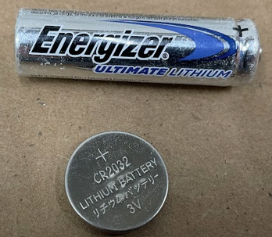
- Made with lithium metal and are commonly used in products such as keyless entry, watches, remote controls, handheld games, and smoke detectors.
- These batteries may be difficult to distinguish from common alkaline battery sizes, but can also have specialized shapes (e.g., button cells or coin batteries) Look for the word “lithium” on the battery to help identify what kind of battery it is.

Lithium-polymer cells (Li-ion, Li-ion cells) rechargeable batteries
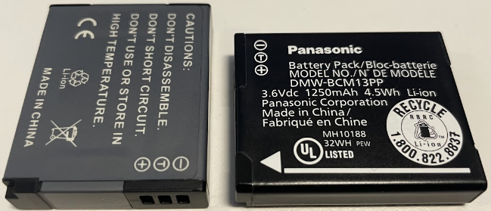
- Commonly found in cellphones, power tools, digital cameras, laptops, children’s toys, e-cigarettes, small and large appliances, tablets, and e-readers.
- Some Li-ion batteries can be removed easily from the products they power, others cannot.

Hazard of Lithium Batteries
In their normal state, lithium batteries are stable and safe to use. If they become damaged, have manufacturing defects, used or recharged incorrectly, or assembled /installed incorrectly they can cause severe injury and damage. This is because lithium is a highly reactive element and can result in hazards not associated with more common alkaline batteries.

Electrical shock
Multiple small batteries can be connected together to create higher voltage and amperage. Contact with energized parts of a battery can shock or electrocute you.

Fire
Lithium is a highly reactive element that may combust and catch fire. Lithium battery fires often occur when the battery is damaged or overcharged. Physical damage can occur while the battery is in use or if it is improperly disposed of in regular solid waste streams.

Thermal runaway
A short circuit can rapidly discharge and degrade the battery which then creates a violent exothermic chain reaction. In multi-cell battery packs, when one cell overheats, it can lead to other batteries overheating and possibly catching on fire. This can also occur when multiple batteries are stored or charged next to each other.

Precautions
It is important to purchase and use devices, batteries, and chargers that have been tested and certified by a Nationally Recognized Testing Laboratory such as UL.

Storage
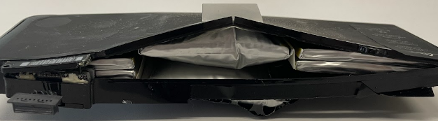
Store lithium batteries in the temperature range the manufacturer recommends. Exposing batteries to temperatures that are too hot or cold can cause damage to the battery. If you do not know the recommended temperature range, keep the battery at normal room temperatures. Extreme heat can degrade and damage the battery, increasing the risk of a fire.
If batteries are damaged, remove them from service. Contact HSRM at hazwaste@umn.edu for disposal instructions.

Charging
Not every battery charger can be used with each battery. Only use battery chargers compatible with the battery being charged. Battery chargers are designed to monitor the battery charge level. Using a battery charger that is not compatible with the battery being charged can lead to overcharging a battery. This can damage the battery to the point of causing a fire.
Disconnect lithium battery powered devices or batteries from chargers once they are fully recharged.
In areas where lithium powered devices or batteries are regularly charged, it is recommended to have a fire extinguishing device nearby. This can include:
- ABC Dry chemical extinguisher
- Class D Fire Extinguisher (for lithium-metal)
- Sand

Disposal
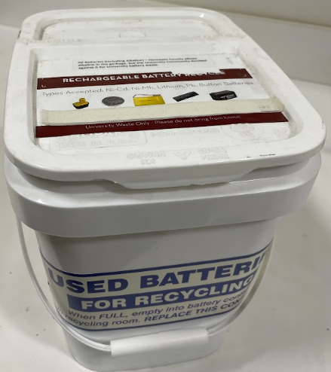
Lithium batteries and lithium battery containing devices can not be disposed of in normal waste containers. Trash compactors may damage a lithium battery, causing it to catch fire.
- Dispose of lithium batteries and lithium battery containing devices in used battery buckets throughout campus.
- This includes items like e-cigarettes/vapes, cell phones, or other lithium battery powered devices.
- Use clear tape to cover battery terminals to prevent short circuiting leading to a fire.
- Tape both ends of small batteries.

Mailing and Shipping
Lithium batteries are considered hazardous materials and have restrictions on how they can be shipped and transported. This may include additional shipping labels and packing materials based on the lithium battery type, voltage, construction, and restrictions on the method of transportation. Improperly shipping hazardous materials could result in fines of up to $27,000 for each incident. If you have questions, contact hsrm@umn.edu.

