Chainsaws, Chippers, and Brush Cutters
Effective Date: May 2018, revision May 2025

PURPOSE
The program establishes minimum safety-related requirements for the use of chainsaws, chippers, and powered brush cutters throughout the University of Minnesota.

SCOPE
The requirements set forth in this document apply to any University employee or student, acting within the scope of their work, academic/educational, or research responsibilities, uses any of the following equipment, regardless of purpose: chainsaws (including pole-mounted chainsaws or powered pole saws), tree/branch chippers, and brush cutters.

DEFINITIONS
Blowdown - A grouping of trees or large branches downed by wind or other weather conditions, which are entangled, in contact with each other, or otherwise situated in a way that presents hazards such as spring poles, compression, and tension. For the purposes of this program, blowdown does not include single, isolated trees or branches, or multiple trees which have been downed due to wind or weather but are not arranged as described above.
Brush cutter – Machines which utilize a metal saw blade(s) to cut brush, tree trunks, and vegetation, usually up to four inches in diameter, at ground level. Included in this definition are “brush mowers” which perform the same function, but are similar to a very large, heavy duty walk-behind lawn mower.
Buck - To cut a felled tree into logs.
Butt – The bottom of the felled part of the tree or branch.
Drop start - The act of starting a chainsaw by pushing the saw away from the body with one hand while simultaneously pulling the starter cord with the other.
Fell/Fall - To cut down trees.
Logging/Logging operations - Operations associated with felling and moving trees and logs for the purpose of harvesting them for economic gain and/or academic/educational purposes. This includes but is not limited to; marking danger trees and trees/logs to be cut to length, felling, limbing, bucking, debarking, chipping, yarding, loading, unloading, storing, and transporting machines, equipment and personnel which are to be used for the purpose of harvesting trees and/or logs for economic gain and/or academic/educational purposes.
Powered - A piece of equipment powered by gasoline or other fuel, or electricity, including a battery or batteries.
Powered pole saw – A powered chainsaw which is mounted at the end of a pole, allowing the operator to reach elevated areas from the ground. This can also be called a pole saw. For the purposes of this program, powered pole saws are considered chainsaws.
Scabbard - A scabbard covers the chain and bar of a chainsaw when the saw is in storage or being transported. It also protects the chain from damage, for instance blunting by contact with concrete floors.
Spring pole - A tree, segment of a tree, limb, or sapling which is under stress or tension due to the pressure or weight of another object, including another tree or limb.
Unqualified person - A person who has little or no formal training and education in electrical safety, and who is not qualified to work on/near exposed, energized electrical parts or conductors, such as overhead power lines.

RESPONSIBILITIES

Employee Responsibilities
- Review the UHS guidance document on the use of chainsaws, chippers, and brush cutters.
- Evaluate work areas to identify unsafe work environments such as fallen trees and trees close to electrical grids.
- Inspect the work areas to identify unsafe work environments such as fallen trees and trees close to electrical grids
- Make sure you are wearing appropriate PPE before beginning any work.
- Make sure a first aid kit is available before beginning any work.
- Inspect all equipment and ensure it is in proper working condition before each use.
- Only use equipment you have been trained to operate safely.
- Follow manufacturer’s instructions on how to safely operate the equipment.
- Immediately remove damaged or suspect equipment from service and report it to your supervisor.
- Immediately report unsafe conditions to your supervisor.
- Attend training upon initial assignment and at least every three years thereafter.

Supervisor Responsibilities
- Review and ensure employees review the UHS guidance document on the use of chainsaws, chippers, and brush cutters.
- Evaluate work areas to identify unsafe work environments such as fallen trees and trees close to electrical grids.
- Supply employees with the right PPE for the required work.
- Ensure all equipment is in good working condition.
- Immediately notify management of unsafe or uncorrected hazardous conditions and ensure all employees are made aware of the hazards.
- Ensure employee training is provided and documented upon initial assignment and at least every three years thereafter.
- Ensure First Aid kits are provided. The contents of the first aid kits listed should be adequate for small worksites consisting of two to three employees. The kits should be restocked on a regular basis and expired items removed.

Departmental Responsibilities
- Ensure work areas are evaluated to identify where employee group who use chainsaws, chippers, and brush cutters.
- Purchase and provide necessary PPE for required tasks.
- Ensure all employees are appropriately trained on proper use of equipment and how to identify and report hazardous conditions.

University Health & Safety Responsibilities
- Maintain the Chainsaw written program.
- Provide training resources.
- Inform affected departments of program requirements.
- Provide technical assistance to areas working with chainsaws and related equipment.
- Monitor implementation of the written program.

PROCEDURE

Equipment requirements
General requirements for all equipment
Equipment covered by this program shall be free of defects or unauthorized modifications which compromise safety. All guards and safety features shall be provided and working correctly.
Minimum safety requirements for chainsaws
- Chainsaws manufactured after 1995 must be equipped with a chain brake and a protective device that minimizes chainsaw kickback and meets the requirements of ANSI B175.1 –1991 “Safety Requirements for Gasoline-Powered Chainsaws.”
- Chainsaws will be operated and maintained in accordance with manufacturer’s instructions.
- Chainsaws shall be equipped with chain catchers.
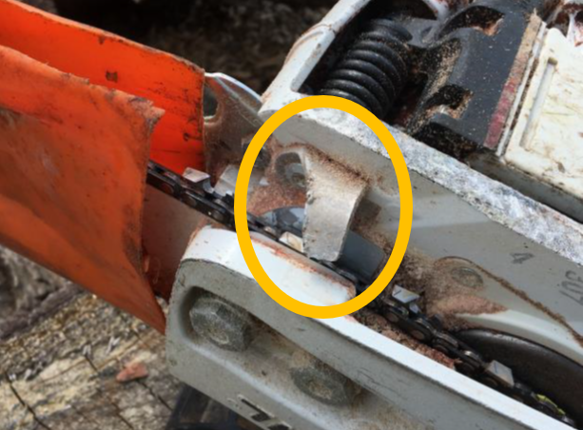
Figure 1: A chain catcher
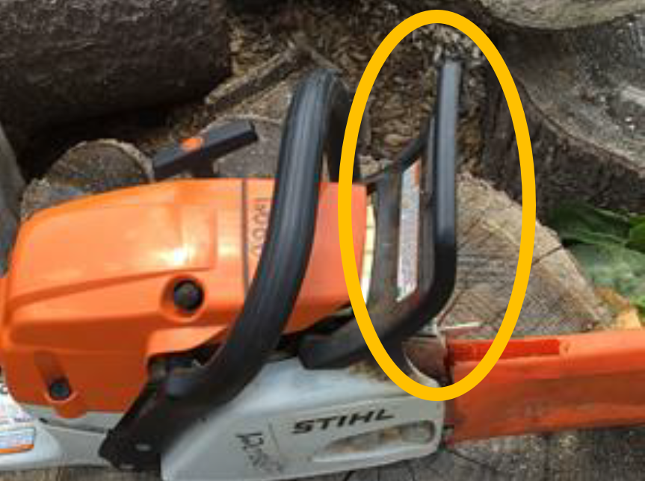
Figure 2: A chain brake/kickback protection device

Minimum safety requirements for chippers
At a minimum, chippers shall be equipped with the following safety features:
- Feed control bar and/or “panic bar” which acts as an emergency stop by stopping and/or reversing the feed rollers. The feed control bar shall be located such that an employee who is being pulled into the chipper would be able to reach it and activate it.
- Flexible rubber curtains or flaps installed at the front of the feed chute. These flaps may help to prevent operators from being pulled into the machine, but primarily prevent objects from being ejected from the chipper and striking the operator or others.
- Discharge spout deflector
- Chipper hood safety latch

Equipment Inspections
All equipment covered by this program shall be inspected prior to each day’s use. If deficiencies are noted upon inspection at any time, the equipment shall be removed from service until repaired.

Specific requirements for inspection of chainsaws
For Chainsaws, the inspection shall consist of at least the following items:
- Chain brake
- Throttle trigger and throttle trigger interlock (lockout)
- Chain catcher
- Handles and guards
- Correct chain number, pitch, and gauge for work
- Chain tension
- Chain lubrication
- Chain sharpness
- Chain depth gauge setting and shape are set correctly
- Guide bar for wear and damage
- Proper idling (i.e. chain does not move while engine is idling)
- Anti-vibration elements
- Fuel and bar oil systems are tight (no leaks)

Job site inspection and arrangement

General requirements
Work sites where chainsaws, chippers, brush cutters, and related equipment are in use shall be arranged so that the actions of one individual will not create a hazard for any other individual.
To the extent allowed by the work at hand, and the geographical constrictions of the work area, the worksite should be set up such that:
- Chainsaws, chippers, and brush cutters are used at least 20 feet from the fueling area.
- The distance between adjacent occupied work areas or nearest person is at least two tree lengths from the trees being felled (if applicable).
- Individuals are not working under, or near activities performed overhead.
- A spotter is designated to ensure that no one enters the work area during cutting activities. The spotter must stand in an area clear of any falling debris.
- Individuals are working in a position or location that is within visual or audible contact with other workers.
- No one is to approach a feller closer than two tree lengths of trees being felled until the feller has acknowledged that it is safe to do so.
- When felling a tree, at least two paths of escape shall be designated and cleared of all brush and other obstacles. These paths should generally be 45 degrees from the stump, in the opposite direction of the planned fall.
- If a wood chipper is used, it must be placed in an area where branches and limbs will not strike employees feeding it, and at least two tree lengths from any trees being felled.
- At the end of each work shift all personnel must be accounted for.

Unguarded, energized overhead power lines
When an unqualified person is working on the ground, or in an elevated position near overhead lines, their location shall be such that the person and the longest conductive object he or she may contact cannot come closer to any unguarded, energized overhead power lines than the following distances:
- For voltages 50kV or below keep10 feet away
- For voltages over 50k or above keep 10 feet plus 4 inches for every 10kV over 50kV
For the purposes of this program, objects which do not have an insulating rating for the voltage involved are considered to be conductive.

Ladders and step stools
Chainsaws may not be used from ladders, step-stools, scaffolds, or similar elevated surfaces, except that properly qualified tree climbers who are tied into trees during operations may use ladders as long as they are adequately secured with two points of attachment to prevent the ladder from tipping.

Carbon Monoxide
Chainsaws and other equipment covered by this program and capable of producing Carbon Monoxide shall not be started or run in areas where insufficient ventilation may exist, such as enclosed, or partially closed buildings and rooms.

Aerial lifts
Aerial lifts, bucket trucks and similar equipment may only be operated by trained, authorized individuals and only in compliance with the University of Minnesota Aerial Lift Safety program, OSHA requirements, manufacturer’s instructions and other best practices.

Working alone
Working alone while operating equipment covered by this program is discouraged. However, working alone is prohibited while felling trees, clearing blowdown or while engaged in logging activities (see “Definitions”). When employees work alone, provisions must be made to ensure that person has means to summon emergency assistance when necessary. This may include ensuring that the person has a cell phone available within close reach while working (assuming adequate cellular coverage in the work area).

First aid supplies
First aid supplies meeting the requirements in the First Aid Section shall be provided at the worksite.

Safe work practices for chainsaws

General requirements
Chainsaws shall be started, operated, stored, transported, maintained, repaired and refueled as specified by the manufacturer and as directed in this section.

Starting the chainsaw
Before starting the chainsaw, the operator shall ensure that all other individuals are safely positioned and that the chain brake is engaged. Chainsaws shall be started while held firmly on the ground with the operator’s foot placed through the handle (to the extent possible), or while held firmly between the legs. Chainsaws shall not be “drop-started”.
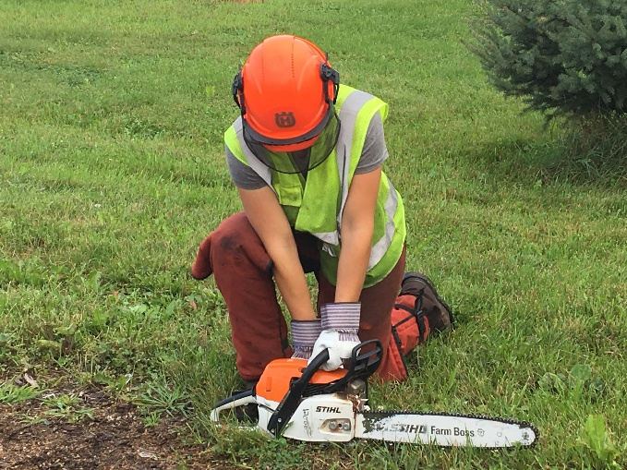
Figure 3: Acceptable starting methods
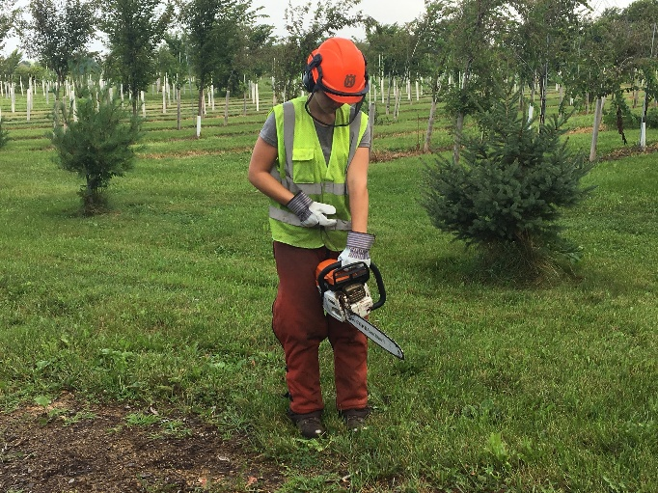
Figure 4: Acceptable starting methods

Proper hand grip on top-handled chainsaws
While cutting or carrying short distances, chainsaws shall be held with two hands. During cutting, operators shall grasp the forward/top handle, with the left thumb wrapped entirely around the handle, and the right hand firmly gripping the rear handle in the same manner.
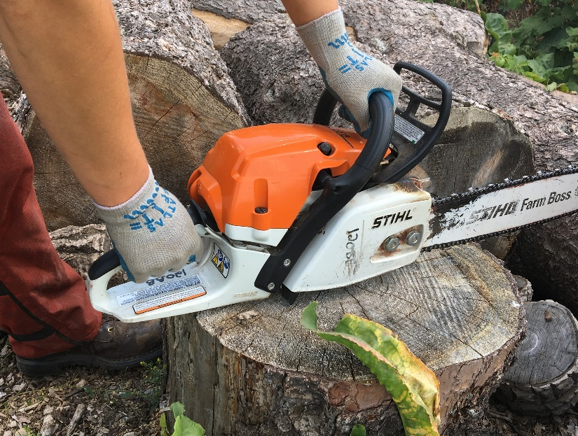
Figure 5: Proper Hand grip for top-handled chainsaws

Refueling the chainsaw
Chain saws shall be fueled at least 20 feet from any open flame or other source of ignition. Chain saws shall not be refueled while running. During refueling, the chain brake shall be engaged. Precautions, such as using a funnel, shall be taken to prevent environmental damage and gasoline from spilling onto hot parts, such as the chainsaw’s exhaust. Chain saws and gas containers shall be placed on the ground during refueling.

Cutting overhead and use of ladders
Chain saws may not be used to cut overhead (no part of the saw may be above shoulder height of the operator). Chain saws may not be used from ladders, scaffolds, or similar surfaces.

Footing
To the extent permitted by the work, and except when working aloft, chainsaws may only be used when the operator has two feet firmly in contact with stable, substantially level ground.

Kickback protection
The operator shall not use the upper part of the nose of the bar for cutting, as this creates significant risk of “kickback”.
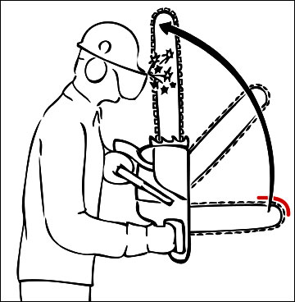
Figure 6: The top half of the nose of the bar is known as the "kick back zone".

Body positioning
While cutting, the operator shall position his/her body such that it is offset to the left side of the chainsaw.
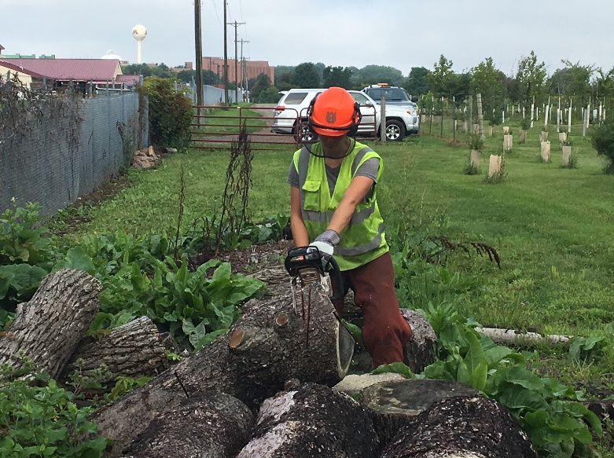
Figure 7: Proper body positioning

Walking with chainsaw
When walking with a chainsaw, the following requirements shall apply:
- Two steps or less:
  - Chain saw may be carried with engine running at idle speed and chain brake not engaged.
  - Chain saw must be carried with both hands.
- More than two steps but less than 20 feet:
  - Chain brake must be engaged OR saw must be off with chain brake engaged
  - Chain saw must be carried with bar pointed behind the operator.
- 20 feet or more:
  - Chain brake must be engaged
  - Saw must be off
  - Chain saw must be carried with bar pointed behind the operator
Transporting and storing chainsaws
When transporting and/or storing chainsaw, for example at the conclusion of the work, the operator shall ensure that:
- The chainsaw shall be shut off with the chain brake engaged.
- Scabbards shall be used to cover the bar and chain while in transport. Hard-sided carrying cases are recommended.
- Chain saws may not be transported in the passenger compartments of vehicles. For the purposes of this program, the passenger compartment of a Sport Utility Vehicle (SUV), station wagon, or hatchback extends from the backrest of the rear seat, forward.
- Hot chainsaws shall not be stored near flammables or combustibles.

Felling trees.
When felling trees, individuals shall ensure that:
- Felling is not conducted in a manner that may create a hazard for anyone.
- When felling a tree, at least two paths of escape shall be designated and cleared of all brush and other obstacles. These paths should generally be 45 degrees from the stump, in the opposite direction of the planned fall, or 135 degrees from the direction of the intended fall. Each path shall be at least 15 feet long.
- Refueling area is at least 20 feet away.
- Domino felling of trees including danger trees is prohibited.
- Danger trees (including lodged and snag trees) are removed using techniques that minimize personnel exposure before work is commenced in the area of the danger tree. If the danger tree is not felled or removed, the area needs to be marked and no work can be conducted within two tree lengths of the danger tree unless it can be demonstrated that a shorter distance will not create a hazard for an employee.
- Each danger tree is carefully checked for signs of loose bark, broken branches, and limbs, or other damage before they are felled or removed. Accessible loose bark and other damage that may create a hazard for the feller or others shall be removed or held in place before felling or removing the tree.
- When a spring pole or other tree under stress is cut, no one other than the feller shall be closer than two tree lengths from where the stress is released.
- Supervisors are consulted when unfamiliar or unusually hazardous conditions exist.
- Prior to beginning a final, felling cut, the operator shall verify that all personnel are safely located, and shall make a loud, verbal announcement, such as “TIMBER” or “FELLING CUT”. This announcement may be supplemented (but not replaced by) hand signals or other visual communication.

Safe work practices for chippers

General requirements
Chippers shall be operated, stored, transported, maintained, repaired and refueled as specified by the manufacturer and as directed in this section.

Starting the chipper
Prior to starting the chipper, the operator shall verify that:
- The chipper’s disc hood is closed and latched and that there are no foreign objects in the infeed area.
- The discharge chute is properly positioned and secured in place to ensure individuals are not struck by discharge.
- All individuals are in safe positions, clear of any hazards such as moving parts, or ejected materials.
- The chipper is secured against unintended movement with wheel chocks or equivalent. A chipper which is properly hitched to a towing vehicle, which has its parking brake set is considered adequately protected from unintentional movement.

Safety monitor
Whenever possible, a specific person shall be designated as a safety monitor. The safety monitor’s sole responsibility is to monitor the loading of material into the chipper and to activate the emergency stop controls if an employee becomes entangled.

Work positions
Individuals operating the chipper shall stand to the side of the chipper intake chute to lessen the chance of being struck by materials ejected from the chipper and to have faster access to emergency stopping features. No individual may stand, sit, climb on, or lean against any part of the chipper while it is running.

Feeding material into chipper
- Operators and other individuals shall keep all body parts, especially hands, away from intake rollers, cutting blades, and other hazardous parts of the chipper.
- When operating a chipper that is parked on a road, it shall be fed from the curb side away from traffic.
- Branches shall be fed into chipper “butt end” first.
- If necessary to push materials into the intake rollers in the feed chute, a wooden push tool or another branch shall be used.
- Shorter branches shall be laid on top of longer branches while being fed into chipper.
- All materials fed into chipper shall be visually inspected prior to feeding, to ensure they do not contain metal objects or other foreign materials. To the extent possible, operators feeding the chippers shall avoid looking at the feeding process to avoid eye injuries from ejected materials.
- Except as noted elsewhere in this program, only one operator at a time shall be engaged in feeding the chipper.
- Smaller objects should be discarded in trash rather than being fed into chipper.

Clearing jams
Whenever possible, jams shall be cleared using tools, branches, etc. so that the operator needn’t place any part of their body in a hazardous portion of the machine.
If manual clearing is necessary, the chipper shall be shut down, and the person clearing the jam shall visually check the cutting disc, intake rollers and other moving parts to ensure that they have come to a complete stop. The key shall be removed and placed under the exclusive, physical control of the person clearing the jam. Locking pins and other safety features shall be engaged to lock the cutting disc in place. The chipper may only be restarted by the person who cleared the jam.

Leaving the chipper unattended
When leaving the chipper unattended, such as at the end of the workday, keys shall be removed and the chipper shall be protected from rolling with wheel chocks or equivalent. For the purposes of this program, leaving the chipper hitched to a towing vehicle whose parking brake is engaged, is considered adequate.

Discharge chute
The discharge chute shall be secured in the proper position prior to starting the chipper and throughout the course of the work. All individuals shall keep all parts of the body clear of the discharge chute and discharged materials. Individuals shall not reach into the discharge chute to clear jams, or for any other reason while the chipper is running.

Personal protective equipment (PPE) and other attire
General attire. Individuals may not wear clothing, jewelry, articles, or other attire which creates hazards to themselves or others. This includes, but is not limited to:
- Jewelry, especially dangling jewelry. This includes all rings, wedding bands, etc.
- Accessories which are worn around the neck, such as neckties, draw strings on “hoodies” or other clothing, necklaces, scarves, ID tags or lanyards.
- Accessories such as keys, headphones, phone belt clips, etc.
- Clothing (including high visibility articles) which are overly bulky, oversized, loose fitting, ripped or torn, unbuttoned/unsecured or otherwise hazardous.
- Shirts must be tucked into pants. Shirt sleeve cuffs must be snug.
- Hair, including facial hair, which is long enough to create hazards must be tied back or restrained when working with equipment that creates entanglement hazards.
- Jewelry, head scarves and other such articles which have religious significance may be worn at the discretion of the wearer, if accommodations are made to provide a level of safety equivalent to not wearing the articles.
Inspection of Personal Protective Equipment (PPE)
All PPE must be inspected prior to each day’s use. Damaged or compromised PPE shall be replaced immediately. This includes ballistic nylon chaps which have been compromised such that the ballistic material has been exposed or deployed.

PPE requirements
All required PPE shall be provided to employees, free of charge.
The requirements outlined are the minimum levels of protection. Individual University departments or locations may develop their own site-specific requirements for Personal Protective Equipment (PPE), as long as those requirements are at least as stringent and protective as those provided.

Required PPE when using chainsaws:
- Leg protection
  - Long pants of denim or similar material, which cover the full length of the leg.
  - Chain saw resistant chaps or chainsaw resistant pants, which cover the full length of the leg are required to be worn unless the operator is climbing a tree or in a aerial lift basket.
- Foot protection
  - During Logging Operations: (See “Definitions”) such as heavy duty logging boots that are waterproof or water repellent and provide cover and support to the ankle, made of cut-resistant material is required; exception: during winter, insulated boots with toe-cap protection may suffice if insulated boots made of cut-resistant material are not available.
  - Required for all other operations: At a minimum, 6” high leather boot with slip-resistant sole. Safety footwear with steel or composite toes is recommended. Steel toes are preferable over composite for chainsaw use.
- Head protection
  - On the ground: ANSI Z89-approved Type 1 or Type 2, Class E hard Hat
  - When climbing: an ANSI Z89 Type 2 Class E hard hat.
- Eye and face protection
  - ANSI Z87-approved safety glasses with side shields (fixed or removable) AND mesh or equivalent face shield integrated with hard hat
- Hearing protection
  - While operating machinery with a noise level of 85 db or greater: ear muffs OR inserts having a minimum Noise Reduction Rating (NRR) of 30. Note: If you are using a chainsaw for more than 1 hour a day or have concerns about noise exposure, please contact University Health and Safety (UHS) at (612)626-6002 for assistance.
- High visibility clothing
  - Required during logging operations, tree felling, or working on the ground within 50 feet of vehicular traffic or other mobile heavy equipment
  - High visibility shirt or vest (ANSI class II or better). Vest must be fastened closed to prevent entanglement. Shirts must be tucked into pants and free of rips, tears, etc.
- Hand protection
  - Wrist-length (non-gauntlet length) leather or utility gloves. Vibration protection is recommended, but not required.

First aid supplies
At least one first aid kit shall be provided of sufficient size and contents for the number of people at the worksite. Kits and supplies shall be restocked as supplies are consumed.

Contents of first aid kits
Each first aid kit shall include at least the following:
- At least four gauze pads (at least 4 x 4 inches)
- At least two large gauze pads (at least 8 x 10 inches)
- Box adhesive bandages (band-aids)
- One package gauze roller bandage at least 2 inches wide
- Two triangular bandages
- Wound cleaning agent such as sealed moistened towelettes
- Scissors
- At least one blanket
- Tweezers
- Adhesive tape
- Latex gloves
- Resuscitation equipment such as resuscitation bag, airway, or pocket mask
- Two elastic wraps
- Splint

Training
Any individual who operates equipment covered by this program shall be required to successfully complete a training program meeting the requirements of this section. Note: Additional OSHA training requirements will apply to any work meeting the definition of “Logging” (See “Definitions”).

Initial training
Individuals who operate equipment covered by this program must successfully complete initial training, prior to operating the equipment.

Refresher training
Refresher training shall be provided to each affected individual at least every three years, and more frequently if/when the individual’s job performance indicates a need for retraining (i.e. he/she has been observed operating in an unsafe manner or has been involved in an accident or near miss).
- Refresher training may be in the form of a brief synopsis of previous training.

Trainer qualifications
All training and evaluations shall be conducted by a suitably qualified instructor who is knowledgeable about this program and its requirements, applicable regulatory requirements, and the equipment at hand.

Documentation
All training shall be documented. Documentation shall include, at a minimum:
- Date(s) of training, including year and beginning and ending times
- Name of instructor
- Names and signatures of all participants
- An outline or brief synopsis of the material covered
- A statement indicating which participants are considered to have completed the courses successfully
See Appendix B for a recordkeeping form. Training documentation shall be maintained by the department, for at least three years from the date of training.

Classroom training
All training shall include a “classroom” component, which shall include at least the following topics (as applicable):
- Responsibilities of the operator
- Hazards of chainsaws, including, but not limited to: Contact with chain (including from kick back), entanglement or strangulation, falls from trees, aerial lifts, etc., falling/flying objects (trees, tree limbs, equipment), weather-related hazards including heat stress, lightning, electrical hazards including overhead or underground power lines, noise, Carbon Monoxide, vibration-related conditions, burns from contact with hot surfaces.
- Hazards of chippers, including but not limited to: Contact with cutting wheels and knives from reaching into hazardous parts or being entangled and pulled into machine, contact with intake rollers, struck by materials ejected from discharge chute, intake, or other parts of machine, weather-related hazards including heat stress, lightning, electrical hazards including overhead or underground power lines, noise, Carbon Monoxide, burns from contact with hot surfaces.
- Hazards of brush cutters, including but not limited to: Contact with cutting blade(s), struck by materials thrown by blades, weather-related hazards including heat stress, lightning, electrical hazards including overhead or underground power lines, noise, Carbon Monoxide, burns from contact with hot surfaces
- How to minimize, eliminate or otherwise mitigate these and other hazards through the proper use of machine guarding, site set up, proper work practices, personal protective equipment, etc.
- The requirements of this program which are relevant to the individual’s duties.
- Emergency procedures including how to shut off the equipment in an emergency and how to summon emergency assistance.

“Hands-on” demonstration and instruction
All training shall include a “hands-on” demonstration and instruction component, which shall include at least the following topics (as applicable):
- The various parts of the equipment in use, including components, hazards, controls, instrumentation, safety features, emergency stops, etc.
- Manufacturer warnings and limitations, from warning labels, manuals, etc.
- Proper methods for conducting inspections, as required by manufacturer
- Proper methods for starting, refueling, operating, maintaining, etc. In the case of chainsaws, this shall include the chain brake and checking and adjusting chain tension.

Operator evaluation (for chainsaw operators only)
Individuals participating in training for chainsaws shall be evaluated at the conclusion of training to verify they have understood and absorbed the information provided during training, and have the required level of competency.
For the initial training, the evaluation shall consist of at least the following:
- Passing a written test (see sample in appendix C). A score of 80% is required to pass, and;
- “Hands on” performance evaluation consisting of tasks that the participant is likely to be required to perform.
For refresher training, the evaluation shall consist of at least a written test (see appendix C). A “hands on” performance evaluation may be required at the discretion of the instructor. In determining whether or not the performance evaluation will be provided, the instructor shall consider factors including; the participants’ general skill and experience, the frequency with which the participant uses the chainsaw (less frequent use implies a greater need to include a skills evaluation), and the other factors as appropriate.
Participants who fail either of the evaluations or who for any reason, fail to satisfactorily complete the training, shall not be permitted to operate chainsaws until they successfully complete the tests. Re-testing may be provided immediately after failing the test, at the instructor’s discretion.

RFEFERENCES
29 CFR 1910.266 Logging Operations

APPENDIX B: Chain saw, chipper and brush cutter safety training documentation

Table 1: Training information
Training Date | Time | Location | Trainer

Training outline

Classroom training
Responsibilities of the operator
- Hazards of chainsaws, including, but not limited to: Contact with chain (including from kick back), entanglement or strangulation, falls from trees, aerial lifts, etc., falling/flying objects (tree limbs, equipment), weather-related hazards including heat stress, lightning, electrical hazards including overhead or underground power lines, noise, Carbon Monoxide, vibration-related conditions, burns from contact with hot surfaces
- Hazards of chippers, including but not limited to: Contact with cutting wheels and knives from reaching into hazardous parts or being entangled and pulled into machine, contact with intake rollers, struck by materials ejected from discharge chute, intake, or other parts of machine, weather-related hazards including heat stress, lightning, electrical hazards including overhead or underground power lines, noise, Carbon Monoxide, burns from contact with hot surfaces
- Hazards of brush cutters, including but not limited to: Contact with cutting blade(s), struck by materials thrown by blades, weather-related hazards including heat stress, lightning, electrical hazards including overhead or underground power lines, noise, Carbon Monoxide, burns from contact with hot surfaces
- How to minimize, eliminate or otherwise mitigate these and other hazards through the proper use of machine guarding, site set up, proper work practices, personal protective equipment, etc.
- The requirements of this program which are relevant to the individual’s duties.
- Emergency procedures including how to shut off the equipment in an emergency

“Hands-on” demonstration and instruction
- The various parts of the equipment in use, including components, hazards, controls, instrumentation, safety features, emergency stops, etc.
- Manufacturer warnings and limitations, from warning labels, manuals, etc.
- Proper methods for conducting inspections, as required by manufacturer
- Proper methods for starting, refueling, operating, refueling, maintaining, etc. In the case of chainsaws, this shall include the chain brake and checking and adjusting chain tension.

Written test (minimum passing score of 80%)

APPENDIX C: CHAIN SAW WRITTEN TEST

Name: Date:

Job title: Location:

Score:
Each question is one point. A minimum score of 80% (20/25) is considered “passing”.
1. Which of the following examples of chainsaw usage would be covered by the University of Minnesota’s policy on the use of chainsaws, chippers, and brush cutters?
a. University employees using chainsaws and chippers to clean up downed trees after a storm
b. Forestry and arboriculture students using chainsaws as part of their academic work
c. Art department students creating artistic works from felled trees
d. Theatre students using a chainsaw in a play
e. All of the above
2. According to the University of Minnesota’s policy on the use of chainsaws; logging is defined as “Operations associated with felling and moving trees and logs for the purpose of ________________ them for economic gain and/or academic/educational purposes.”
a. Studying
b. Harvesting
c. Destroying
d. Burning
3. If an individual covered by the University of Minnesota’s “Safety requirements for chainsaws, chippers, and brush cutters” program, is engaged in “logging operations”, they must follow the additional requirements found in OSHA’s logging standard (1910.266).
a. True
b. False
4. Most chainsaw, brush cutter, and chipper accidents result from lack of training, unsafe operation, or assuming a job is “too small” for appropriate PPE.
a. True
b. False
5. Which of the following is a recognized hazard of chainsaw use?
a. Accidental contact with chain/blade, perhaps from kickback
b. Operator being struck by falling trees, branches, limbs
c. Clothing or jewelry snagged by moving chain
d. All of the above
6. All chainsaws manufactured after 1995 must be equipped with a ____________.
a. Panic Bar
b. Safety Latch
c. Throttle Trigger
d. Chain Brake
7. All chainsaws must be equipped with chain catchers.
a. True
b. False
8. In general, employees may not place themselves, or any conductive object, closer than _____ feet to overhead, energized powerlines?
a. Eight feet
b. 10 feet
c. 12 feet
d. 20 feet
9. Under no circumstances may a chainsaw be operated by a person who is working alone.
a. True
b. False
10. How often must chainsaws be visually inspected?
a. At the start of each day’s use
b. At the start of each day’s use and again after lunch
c. Weekly
d. Monthly
11. Under the University of Minnesota policy, a student or employee who uses a chainsaw for any reason must:
a. Complete a training program which complies with the University of Minnesota’s chainsaw, chipper, and brush cutter policy
b. Pass a medical evaluation
c. Pass a vision test to ensure he/she can properly inspect chainsaw chain
d. Be able to climb a ladder while carrying a chainsaw
12. Which of the following should be included as part of the pre-use inspection of a chainsaw?
a. Chain brake
b. Chain tension, lubrication and sharpness
c. Guide bar wear and damage
d. Proper idling
e. All of the above
13. In felling trees, the role of a spotter is to guide the chainsaw operator where to fell a tree.
a. True
b. False
14. ANSI-approved safety glasses are required for ALL work activities covered by this program.
a. True
b. False
15. While cutting with a chainsaw, the operator shall hold the saw with two hands, and both thumbs wrapped around the handles, except:
a. When cutting overhead
b. When working from a ladder or step stool
c. When bucking and limbing
d. None of the above, a chainsaw must always be held in this manner while cutting
16. Which of the following is prohibited when starting the chainsaw?
a. “Drop starting” chainsaw
b. Having helper standing right next to employee starting chainsaw
c. Not having the chain brake engaged
d. Putting on required PPE after chainsaw is started
e. All of the above are prohibited
17. When cutting trees which are in a relatively horizontal position (i.e. laying on the ground), the operator’s body should be positioned so that:
a. The saw is slightly offset to the right of the operator’s body
b. The saw is directly in front of and centered on the operator’s body
c. The saw is centered above an operator’s leg
d. Trees in a horizontal position rarely need to be cut
18. When trees are being felled, what is the minimum distance from the feller to adjacent occupied work areas and/or nearest person to the feller/trees being felled?
a. Six feet
b. Any distance deemed safe by the feller
c. Two tree lengths
d. No one should be within sight of the feller
19. Working alone when operating a chainsaw is prohibited in all of the following scenarios, except:
a. Felling a tree
b. Clearing blowdown
c. Logging
d. Clearing isolated trees laying down across roads
20. Which of these statements is true concerning first aid kits at a worksite where chainsaws are being used?
a. No first aid kit is required
b. First aid kits, with an adequate supply for the number workers present, is required at the jobsite.
c. There are minimum requirements for contents of first aid kits.
d. There must be at least one Emergency Medical Technician onsite
e. B and C
21. Which item would NOT violate the requirements for the chainsaw operator’s general attire:
a. Jeans
b. Necktie
c. Charm bracelet
d. Untucked and unbuttoned button-up shirt
22. What is the minimum level of foot protection required for any work covered by this program?
a. Sneakers/tennis shoes with open toes and heels
b. 6” high leather boot with slip-resistant sole.
c. Rubberized shoes/boots
d. 8” logger boots with Kevlar coating and composite toes
23. When walking with a chainsaw, the bar should be pointed ____________.
a. Forward
b. Backward
c. Up
d. Down
24. When felling a tree, at least ____ path(s) of escape should be planned and obstacles removed in the path(s). The path(s) should generally be _______ to the planned direction of the fall of the tree.
a. Two, Parallel
b. One, Opposite
c. Two, Away from the tree diagonal (45 degrees)
d. One, Parallel
25. PPE which is required by the employer must be provided to the employee _________.
a. At no cost to the employee
b. Prior to allowing the employee to perform work requiring PPE
c. In good condition, free of any defects
d. All of the above
ANSWER KEY:
1. e
2. b
3. a
4. a
5. d
6. d
7. a
8. b
9. b
10. a
11. a
12. e
13. b
14. a
15. d
16. e
17. a
18. c
19. d
20. e
21. a
22. b
23. b
24. c
25. d

