Fungal Growth in Walk-in Coolers (Cold Rooms)

Revised:
Wherever indoor moisture is present fungi (mold) may become a problem. Mold growth is frequently found in cold rooms due to high humidity and limited air exchanges. Exposure to mold may cause allergic reactions and worsen existing respiratory conditions such as asthma. Check out tips on how to identify areas where fungi may be hiding and to view fungal photos.
Commonly reported symptoms to mold exposure are:
- nasal and sinus congestion
- cough
- wheeze/breathing difficulties
- sore throat
- skin and eye irritation
- upper respiratory infections (including sinus)

How to Identify Problem Cold Rooms
- Rusting cans or other metal surfaces and mold on non-porous surfaces are indicative of high humidity.
- Mold on storage containers and other surfaces may pose a health risk. Fungus may be light colored or dark in appearance.
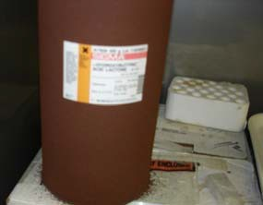
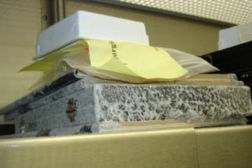
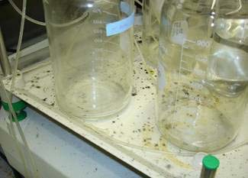

What to Do When a Problem is Identified
- Contact your building service coordinator. They should contact Facilities Management at 624-2900 to arrange for abatement.
- Contact DEHS 626-6002 to inspect coolers or other areas of health and safety concern.
- Follow the Environmental Health and Safety’s Fungal Abatement SOP for all abatement procedures. Proper personal protective equipment is required.
- Remove all rusted metal chemical containers and dispose of them properly per the Hazardous Chemical Waste Management Guidebook.
- If a cooler’s relative humidity is greater than 70%, or the dew point is greater than 32º F in a 40 degree cooler, request repair. See a psychrometric chart to determine dew points.

How to Prevent Mold Problems
- Promptly clean up all spills.
- Report any facilities leaks from plumbing, etc. to the FM call center at 624-2900.
- If it is necessary to store paper products in a cold room, place them in a closed plastic container.
- Keep the door firmly shut to prevent water condensation inside the cooler.
- Do not use cardboard storage containers.
- Do not store books or cardboard slide holders in cold room.
- Routinely clean surfaces (shelves, bench tops, equipment, etc.) inside cold rooms to prevent mold growth.
- Keep the use of wood, Styrofoam, and other porous materials to a minimum.
- Place a gauge in cold room to monitor humidity - should be less than 60%. Mold growth starts at 70%. Some objects stored in cold rooms may be cooler than the air temperature. These surfaces will have a higher relative humidity and be more prone to support fungal growth.
