Work-from-Home Ergonomics

Choosing Your Workspace
- Choose a desk that has enough clearance for your knees, thighs, and feet. Avoid sitting where you cannot slide in under the desk.
- Avoid working on the couch - as comfortable as it may feel, it causes a C shape for your back which hurts your spine. A couch can work for short times if a pillow is placed behind the back to provide lumbar support.
- Position screens at a right angle to windows and away from harsh lighting. Avoid areas with direct sunlight or where lighting is directly behind, above, or in front of you.
- Use your laptop at a desk or table if you can, or place it on a flat smooth surface with a thin pillow underneath if you’re using it on your lap. Never place a laptop directly on pillows or other soft materials as it may cause the fan to overheat.

Adjusting Your Chair
- Choose a chair with a firm back, arms that can support your elbows when held close to your body, and that can go low enough that your feet can completely touch the floor when your thighs are parallel to the ground. Our Setting Up Your Ergonomic Office Space fact sheet provides further guidelines.
- Try to find a chair that’s the right depth for you - when you sit completely back in the chair, you should have about 3 fingers of space between the front of the chair and the back of your calf.
- You may be able to work with your department to make arrangements to temporarily bring your office chair home. Contact your supervisor to discuss. If you come to campus to pick up any equipment, ensure you are following social distancing recommendations.
- If you’re using a chair from home, consider adding a pillow or rolled up towel for back support, to make the seat plusher, or to better support your elbows if your chair arms don’t adjust.
- Adjust your chair height so that your wrists are straight, and the keyboard is positioned directly beneath your hands. Your shoulders should be relaxed and not pushed up.
- If you need to raise your chair up to reach the proper arm height, you may need to add a footrest to elevate your knees if your thighs are not parallel to the ground.
- At-home footrest options include empty boxes, garbage cans on their side, old books, storage containers, etc. Get creative!

Laptop/Monitor Set-Up

Revised:
- If you are using a laptop, strongly consider using an external full-size keyboard and mouse, rather than the built-in ones. The larger size allows for better ergonomics and a less awkward posture.
- With department permission, you may be able to bring your accessories from work home with you temporarily, if you do not have any available.
- Adjust your monitor or laptop screen so the top of the screen is approximately level with your eyes. (Bifocal wearers may need to adjust lower to avoid tilting their head back.)
- Angle your screens so that you are not bending forward or hunching your shoulders to view them. You are aiming for a neutral neck posture, with your head balanced on top of your spine. Sometimes it can be useful to ask someone else to look at your posture to verify it’s correct.
- At home, you can use stacks of books, boxes, etc. to raise your screens up. For laptops, laptop risers are available online.
- Position your screens about one arm’s length away from you. Some users may need to adjust closer or farther depending on their vision, keeping neutral neck posture in mind.
- If you are using two screens, adjust them so that they are as close as possible to the same height and distance away from you. If one of your monitors is your primary, center it on your keyboard. If you use them equally, place them side-by-side equally in front of your keyboard.

Accessories
- Keep your keyboard and mouse on the same level and as close to each other as possible.
- Try to keep your wrists as straight as possible, with your upper arms close to your body and your elbows supported by the arms of your chair. Move the mouse from the elbow and not the wrist to avoid strain.
- If you are regularly using the phone, consider putting it on speaker or using a headset. Avoid cradling the phone between your head and neck, especially cell phones.

Standing Workstations
- You can construct your own sit-stand workspace at home. If you choose to do this, make sure that you make it the correct height so that your elbows are at a 90° angle and your wrists are straight when you are using the keyboard. Also, the screen should be high enough that you can maintain your neck in a neutral posture, as discussed above.
- Some common options at home may be dressers, countertops, bookcases, building your own from books, cardboard, or other supplies, or elevating a desk/table in your home using books or other materials. Make sure whatever you choose still allows for correct monitor, keyboard, and mouse placement!
- Low-cost sit-stand desk options are available at the UMN Ergonomic Showroom.
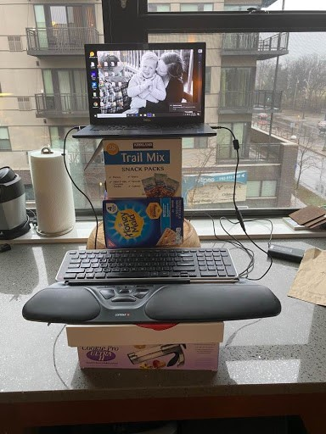

General Wellness
- Take breaks! Set a reminder on your calendar or phone to get up and stretch every half hour or so.
- You can use our variety of stretching and relaxation videos as guides. Make sure to listen to your body and don’t do any stretches that are painful. Always listen to professional medical advice.
- Rest your eyes by following the 20-20-20 rule: every 20 minutes take a 20 second break to look at something 20 feet away.
- It can be helpful to take some time to relax during stressful times— try one of our stress reduction videos featuring breathing techniques and seated yoga.

