Workrite Height & Angle Footrest
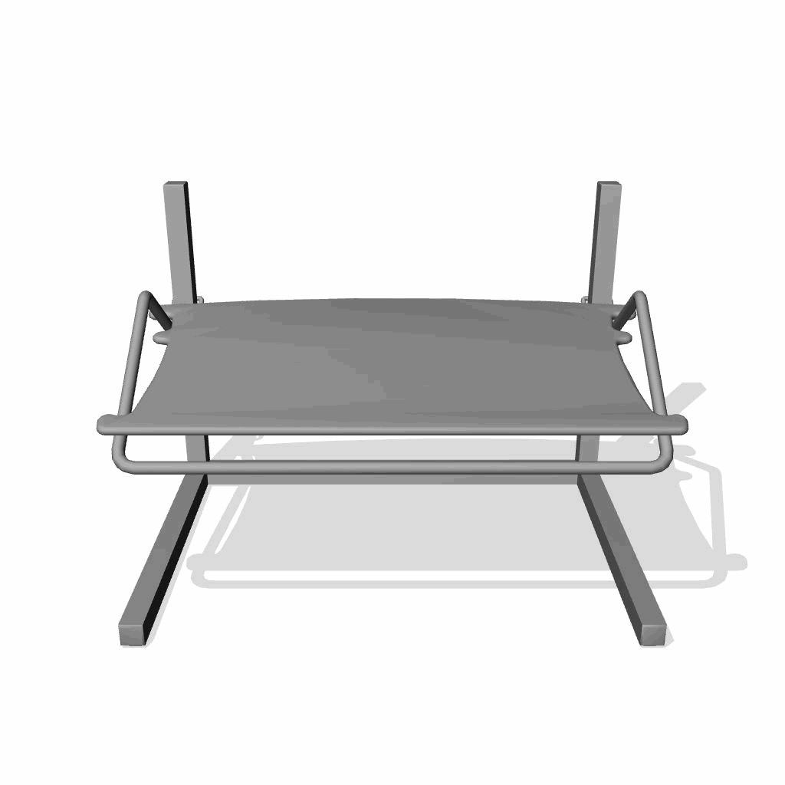

Ordering Information
Grand Total Price, note that all prices are approximate and are subject to change by the distributor or manufacturer: | $191.86
Manufacturer: | WRT
Part Number: | 215-WIDE
Quality | 1


Ordering Information
Innovative Representative: Debbie Lazcano-Stai, Account Executive
Phone Number: 952.567.1968
Email: DStai@innovativeos.com

