Evoluent Mouse

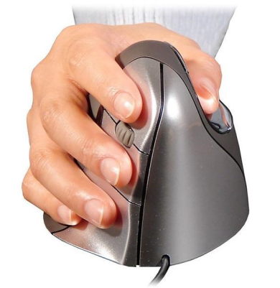

Revised:

Product Information
- PC and Mac compatible
- Vertical position reduces wrist strain
- Available in small and large sizes
- Wired and wireless options
- Right and left hand models

Ordering Information
Price: | $75-$110 (depending on style and size)
Manufacturer: | Evoluent
Distributer: | UMarket: CDW
To Order: | Order at the UMarket at: www.umarket.umn.edu

Cost For Different Mouse Styles and Sizes
Right-Handed Wired: | Small (part number: 2289733) is $75, Large (part number: 2204347) is $80
Right-Handed Wireless: | Small (part number: 3175151) is $100, Large (part number: 2692392) is $100
Left-Handed Wired: | Small not available, Large (part number: 2195354) is $75
Left-Handed Wireless: | Not available

More options available at www.evoluent.com

