Dry Ice

Revised: Aug 2026

Dry Ice Properties
Dry Ice is a solid form of carbon dioxide. It can be obtained in many forms, including flakes, pellets or blocks. Dry ice is extremely cold and will sublime (transition from solid to gas directly) at –78.5° C (-109.3° F). As it is comprised solely of carbon dioxide, it is non-combustible.

Health Hazards
- Burns: Handling dry ice with bare hands can cause cryogenic burns to the skin. Dry ice tends to stick to exposed skin, worsening the burn.
- Asphyxiation: Carbon Dioxide sublimated from dry ice can displace oxygen in areas with poor ventilation. This may cause asphyxiation.

Proper Handling
- If a package containing dry ice is bulging, it might be under pressure. Do not attempt to open a bulging dry ice container yourself. A sudden release in pressure might cause the package to burst.
- Do not directly touch dry ice. Use loose fitting cryogenic gloves in addition to scoops or tongs when working with dry ice.

Storage
- Do store dry ice in areas with limited ventilation. Examples would be unvented storage closets, cold rooms, or other confined areas.
- Do not place in airtight containers.
- Do not store dry ice in sinks or other fixtures. Dry ice can damage plumbing fixtures.

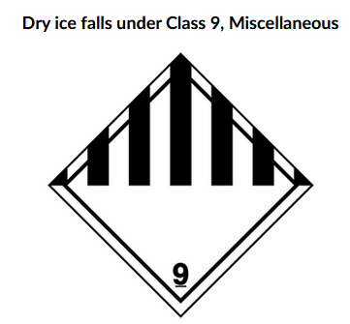
Transportation and Shipping
Figure 1. Department of Transportation required labeling for Dry Ice. Accompanied by text "Dry ice falls under Class 9, Miscellaneous"
- Only transport dry ice in appropriate containers.
  - Designed to withstand low temperatures.
  - Non-sealable.
- Containers must have labels or warnings for dry ice attached.
- Do not package and ship dry ice unless you have taken hazardous materials shipping training. Shipping requires applicable DOT labeling (Fig. 1).
- When shipping, dry Ice must also be marked with “UN1845, Dry ice.” Packages must also have up arrows on opposite sides of the package.

Disposal
- Allow dry ice to sublimate in a well ventilated area.
- Do not dispose of dry ice in waste containers.

