Perchloric Acid

Revised: Aug 2026

Chemical and Physical Properties
Perchloric acid is a colorless, oily liquid with no significant odor at room temperature. It is a strong acid and a powerful oxidizing agent. Perchloric acid can form explosive mixtures with organic materials, reducing agents, and certain metals. Anhydrous and concentrated forms are highly reactive and may detonate upon contact with combustible substances or under mechanical shock or exposure to heat. The acid is corrosive to metals and biological tissue.

Health Hazards
Acute Effects: The following acute (short-term) health effect may occur immediately or shortly after exposure:
- Corrosive to skin and mucous membranes. Skin exposure can cause burns and irritation, and the compound can be extremely harmful to the digestive tract, if swallowed.
- Inhalation may produce dyspnea, pleuritic chest pain, upper airway edema, pulmonary edema, hypoxemia, bronchospasm, pneumonitis, and persistent pulmonary function abnormalities. Airway hyperreactivity has also been reported. The onset of respiratory symptoms may be delayed for several hours.
Chronic Effects: The following chronic (long-term) health effects can occur at some time after exposure and can last for months or years:
- Repeated exposure to dilute solutions may cause skin rash and possible sensitization.
- Perchloric acid, given orally or subcutaneously to rats and mice, showed a specific antithyroid action, and also induced abnormalities in hepatic, renal, cardiovascular and hemopoietic functions.

Accidental Exposure
Any accidental exposure requires immediate medical attention. Call 911 for medical assistance, and take the following steps while emergency assistance is enroute.
- Inhalation: Immediately vacate the exposure area and move to fresh air.
- Skin Contact: Immediately remove contaminated clothing and wash the exposed area for at least 15 minutes. Dispose of any contaminated clothing as hazardous waste.
- Ingestion: Rinse mouth immediately and drink plenty of water. Do not induce vomiting.
- Eye Contact: Remove contact lenses. Flush eyes at the emergency eyewash station for 15 minutes.

Special Hazards of Perchloric Acid
- Perchloric acid is a corrosive liquid. It is not combustible itself but, as an oxidizer, it can increase the potential for ignition or explosion of other compounds.
- Heating of perchloric acid may cause an explosion.
- Combustion may produce hazardous fumes and vapors including hydrochloric acid and chlorine gas.

Safe Work Practices

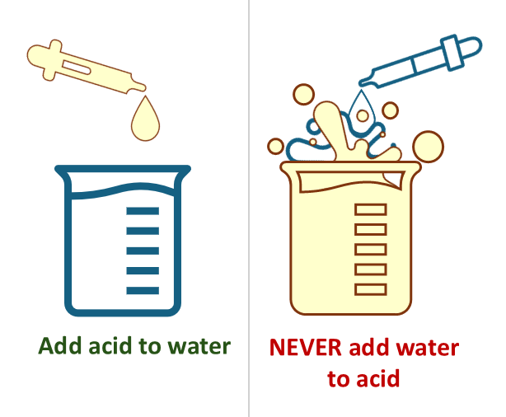
Safe Use
- Whenever possible, substitute perchloric acid for a less hazardous alternative.
- Heating perchloric acid (e.g. digestion oorganic samples, exothermic reactions, etc.) requires that the work is performed in a stainless steel fume hood that is equipped with a wash down system.
  - If you suspect perchloric acid was used in an unapproved fume hood, contact HSRM at (612) 626-6002 for perchloric residue testing. Do not attempt to clean a contaminated hood yourself.
Fig 1. Always add acid slowly to water to reduce heat of dilution. Reversing the order can cause the solution to rapidly boil and splatter.

- When preparing a dilution of perchloric acid, always add concentrated acid to water (Fig. 1).
- Ensure that an eyewash and safety shower are nearby prior to use.
- Prior to working with perchloric acid, make sure any organic material (i.e. paper, Kimwipes, organic chemicals, etc.) and any non-essential chemicals are removed from the fume hood.
- Perchloric acid is incompatible with rubber and some types of grease; plan accordingly.
- To follow best practices, perform your work with perchloric acid inside of a non-reactive secondary containment tray (i.e. glass) that is large enough to contain your entire reaction vessel if it were to spill. Stock bottles must be similarly kept in non-reactive secondary containment at all times.

Storage
- Always store at room temperature and away from heat sources and open flames.
- Perchloric acid is a strong inorganic mineral acid which is not compatible with organic acids or materials and must be stored separately.

Spill Information
- Perchloric acid is extremely hazardous once it has dried. Do not allow a perchloric acid spill to dry.
- Neutralize a small spill by completely covering it with soda ash. Cover the area liberally with water and sop up with wet rags. Keep the rags wet with water and place in a sealed plastic bag. Never use paper towels or other combustible material to clean up a perchloric acid spill. If you are uncomfortable with cleaning up a small perchloric acid spill, evacuate the area and request HSRM assistance.
- Mop water and rags from the spill clean-up should be disposed as hazardous waste. Contact the Regulated Waste Program (612) 624-1604 as soon as possible to pick up the spill materials.
- In the event of a large perchloric acid spill, evacuate the area, call 911, and request HSRM spill assistance. Do not attempt to clean up the spill yourself.

Waste Disposal
Dispose in unused waste containers or containers that have previously held perchloric acid solution. DO NOT re-use containers that previously contained incompatible materials. Ensure that the waste container is made of compatible material. Do not mix perchloric acid containing waste solutions with other liquid waste.

