Shared Equipment

Revised: Aug 2026
Research groups often share pieces of equipment that are too large or expensive for just one group to purchase. Examples of shared equipment and spaces include autoclaves, centrifuges, cold rooms etc. Often the diffuse responsibility of shared equipment leads to problems with:
- Unauthorized/insufficiently trained users
- Scheduling use
- Unsafe situations from lack of understanding of other hazards present in the area
- Processes for reporting and resolving equipment problems

Groups with shared equipment or spaces should determine:
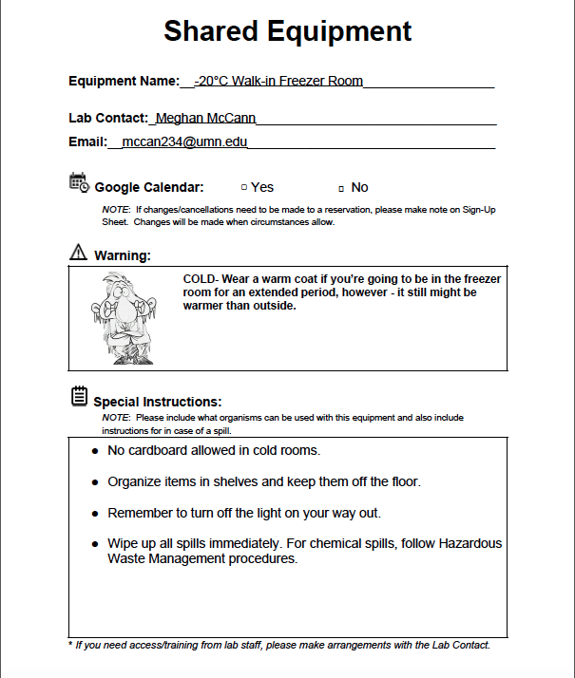
- Who to contact for training
- Who to contact to handle equipment problems
- How to schedule time for use (e.g., a shared google calendar for the equipment)
- How to identify and communicate which pieces of equipment are “shared”, Use of standardized signage is recommended. Brightly colored signs help make this obvious (e.g., see example above of a sign used in CEMS to indicate shared equipment).
- How quality control, calibration and maintenance will be performed
- What warnings should be posted by the equipment to alert those around potential hazards
- What special instructions (if any) the equipment user should be warned of and reminded of
- Standardized SOPs reduce research errors in results, if they are followed. Posting these next to the shared equipment is recommend
Fig 1. Sample shared equipment form prepared by CEHMS

Individuals wanting to use shared equipment or spaces should:
- Never use another group’s equipment, without permission, especially if it is not shared
- Look for signage indicating equipment is for shared use
- Get proper training on shared equipment. Do not use equipment unless you have been trained by the equipment owner
- Reserve time on the shared equipment schedule. Note: If you do not have access to an equipment calendar, that means the equipment manager does not have you documented as a trained user. Talk to the contact listed.
- Clean up shared spaces after use
- Replace any depleted lab supplies

